**Fabric Dataflow gen1**

First create a pipeline

Workspace 🡪 new item 🡪 data pipeline

Create a pipeline

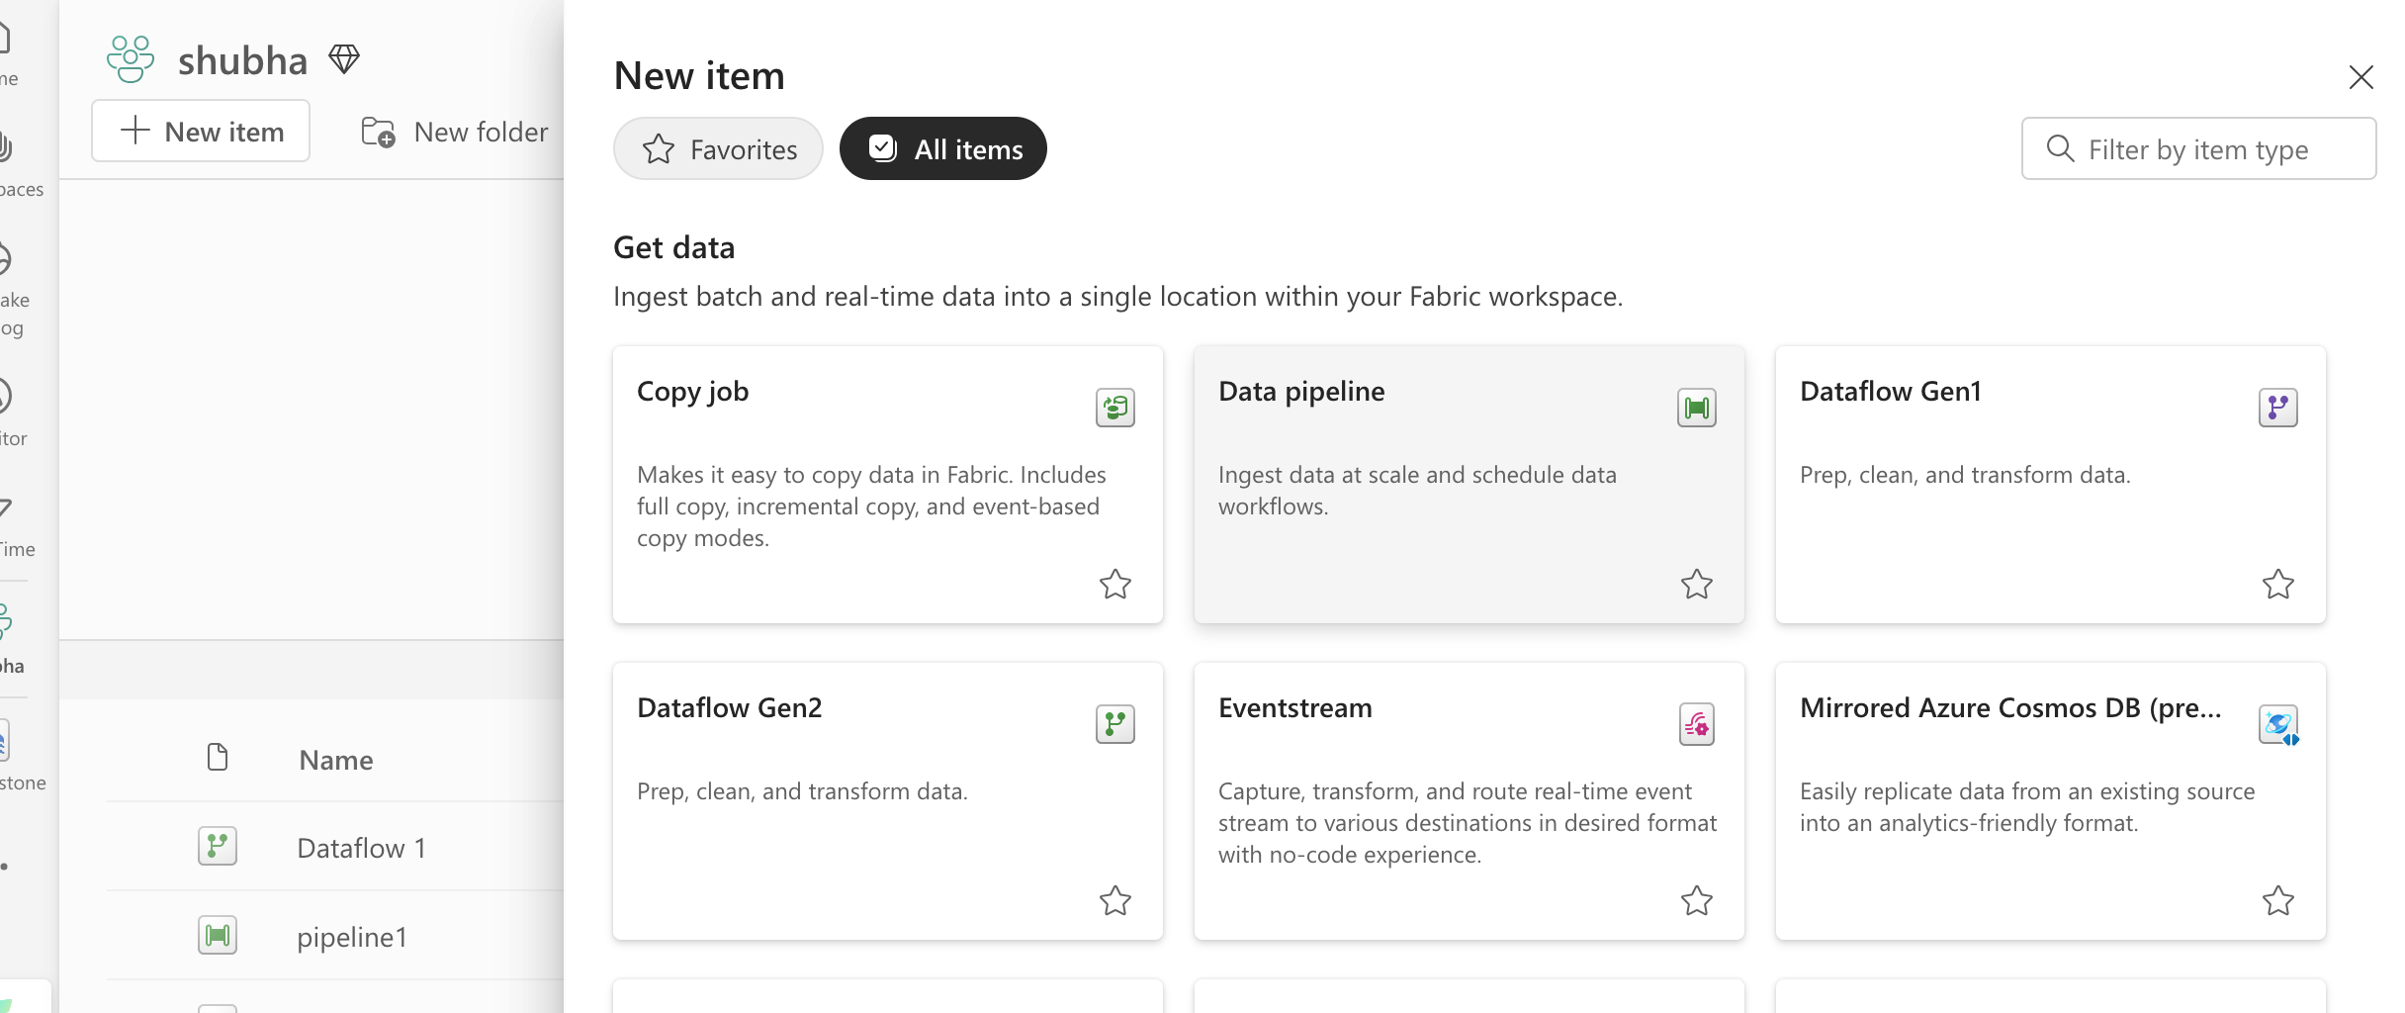 Pipeline is creataed successfully , now drag and drop dataflow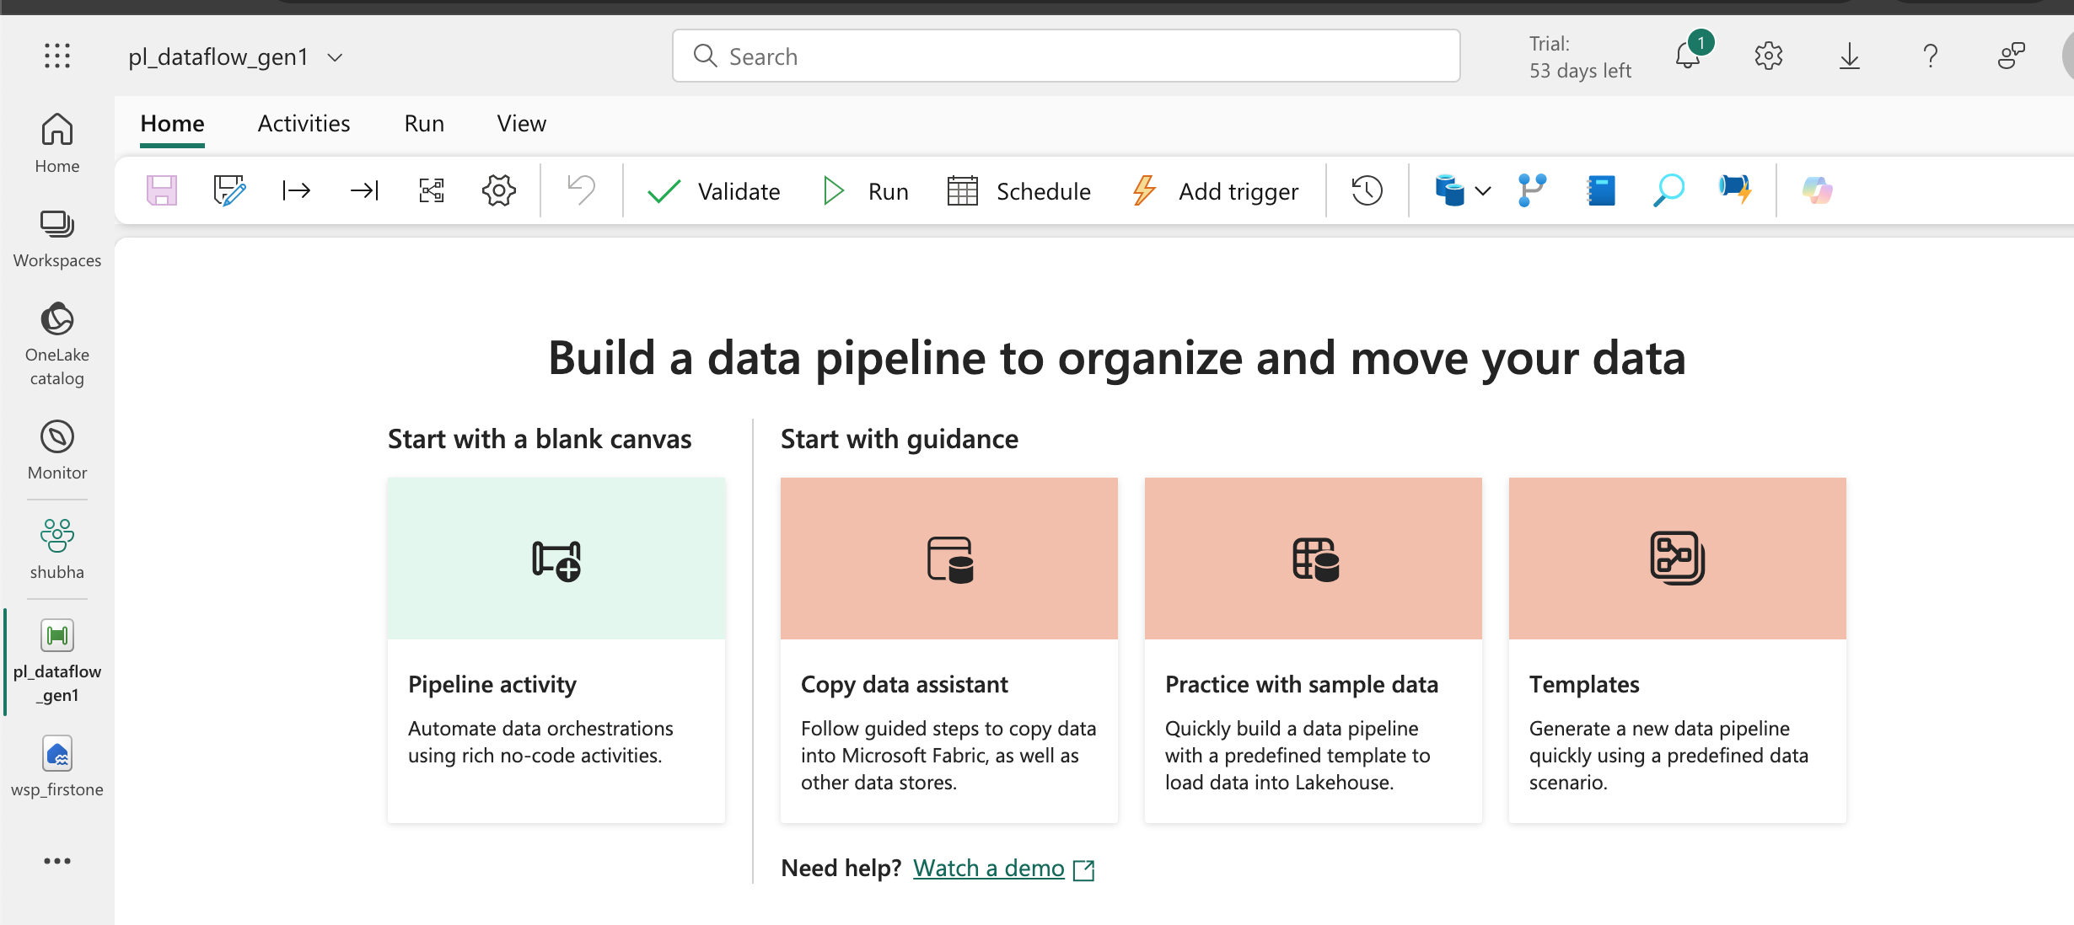 Give your workspace name 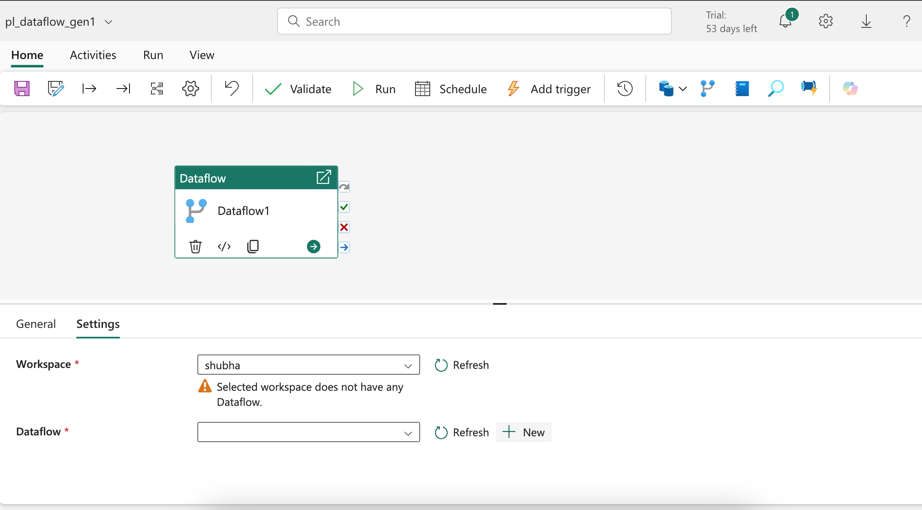for dataflow , + new and create 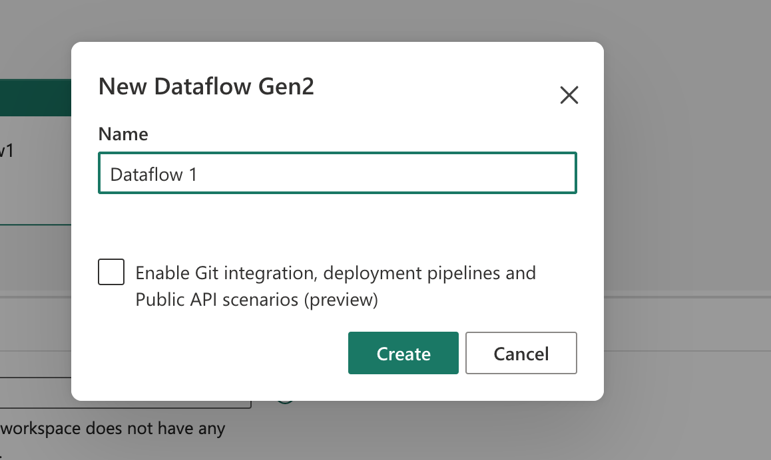dataflow is created successfully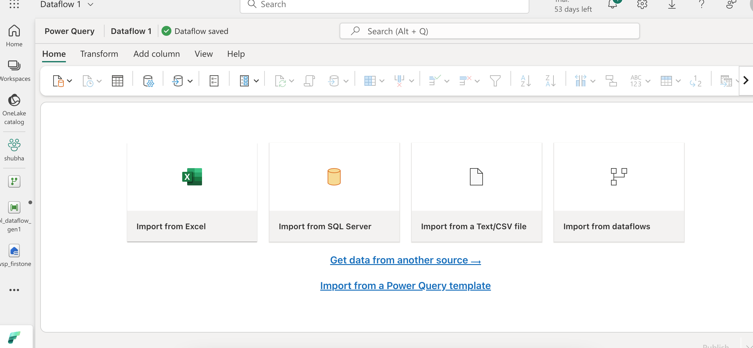Now to get the source we need to create a connection , for that click new source 🡪 choose source 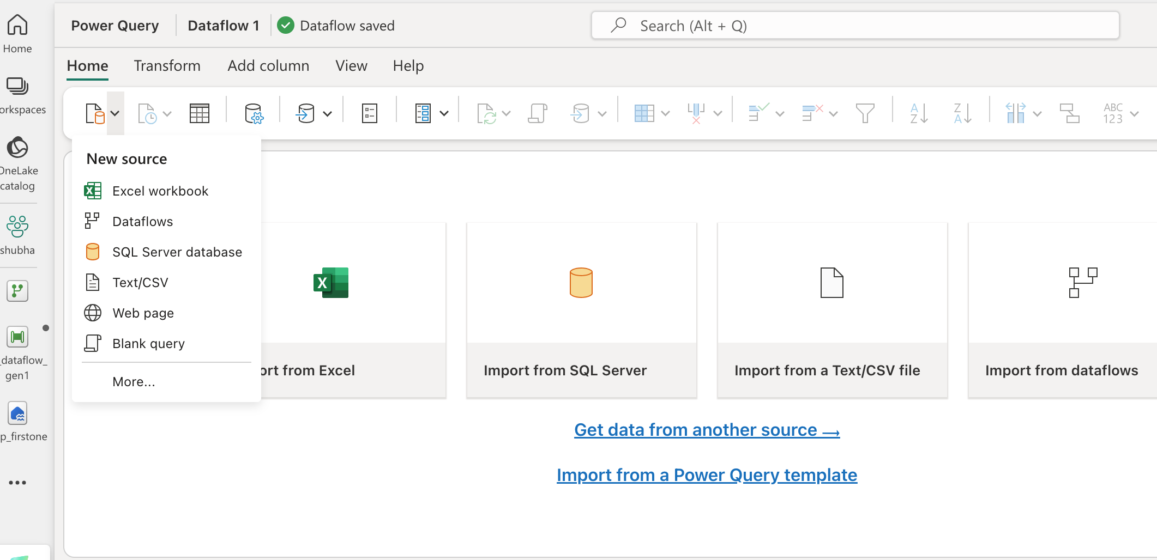to view more option, select more 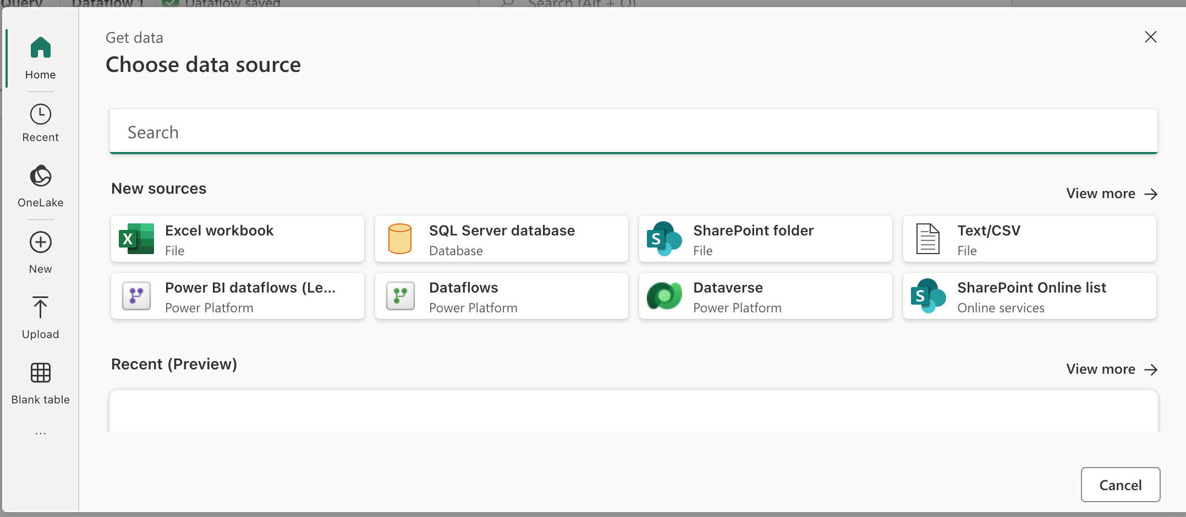here we can search for any source that we want , I am looking for lakehouse so search it and select it

Once lakehouse is selected , we it create a connection automatically to all the available workspaces 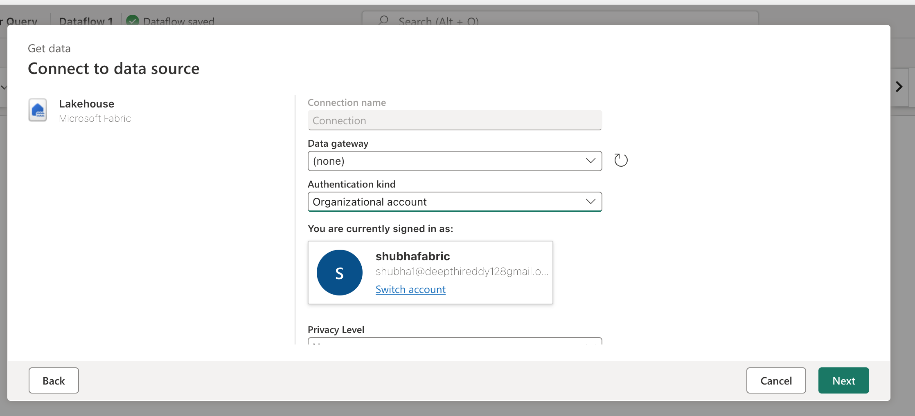Now we want to select which workspace lakehouse we want and what is the source from the lakehouse file or table 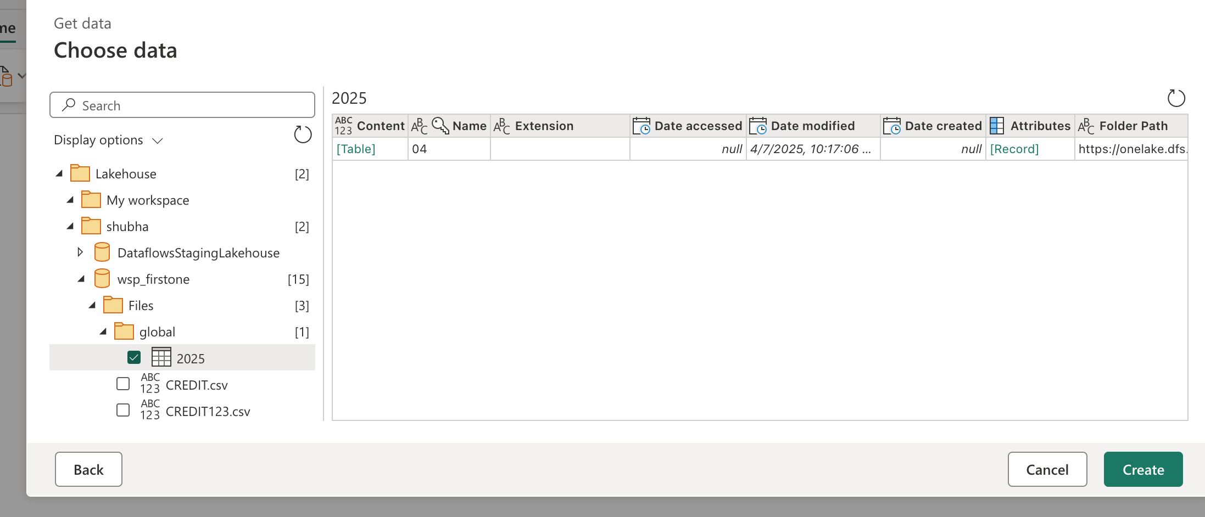here we see folder to get the data , we need click the link table to get the data

My folder has subfolder , so need to click 3 times to get the data

connection to lakehouse is created successfully

In the right hand side , we have query setting option

here we have all the steps performed previously (like it will store every step we will perform in this dataset or pipleine or connection) and if we want to undo any step we can do it here by deleting the appropriate step we want to undo

to check the diagramatic view , click on diagram symbol below the query setting 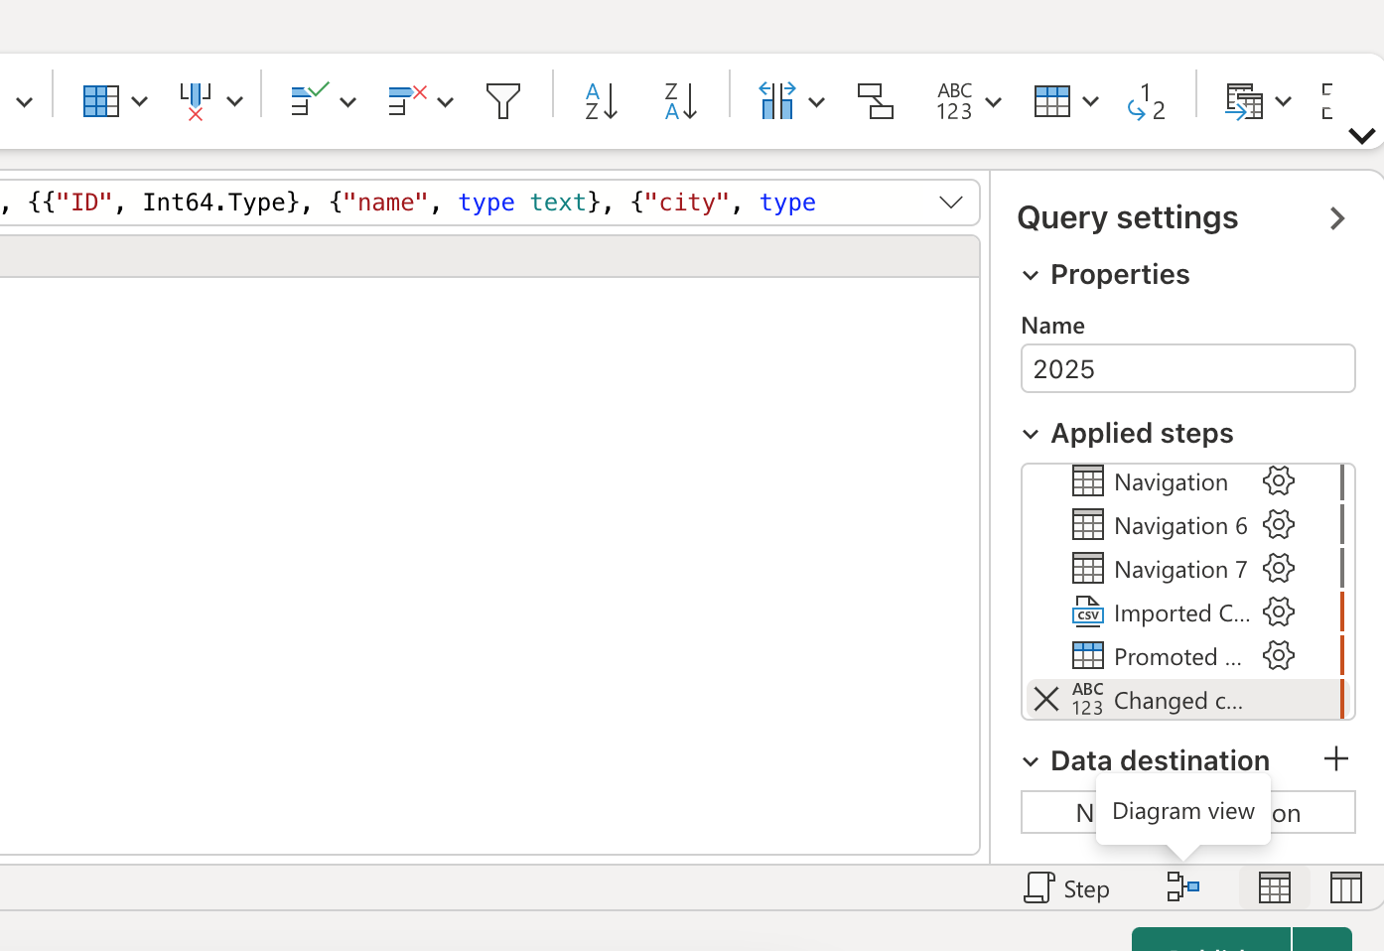 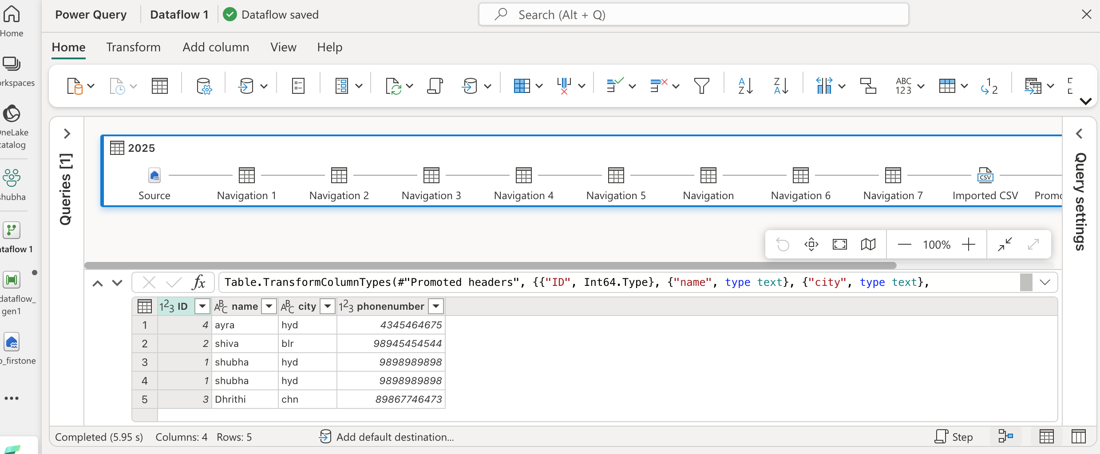 to collapse these steps , we can use collapse option 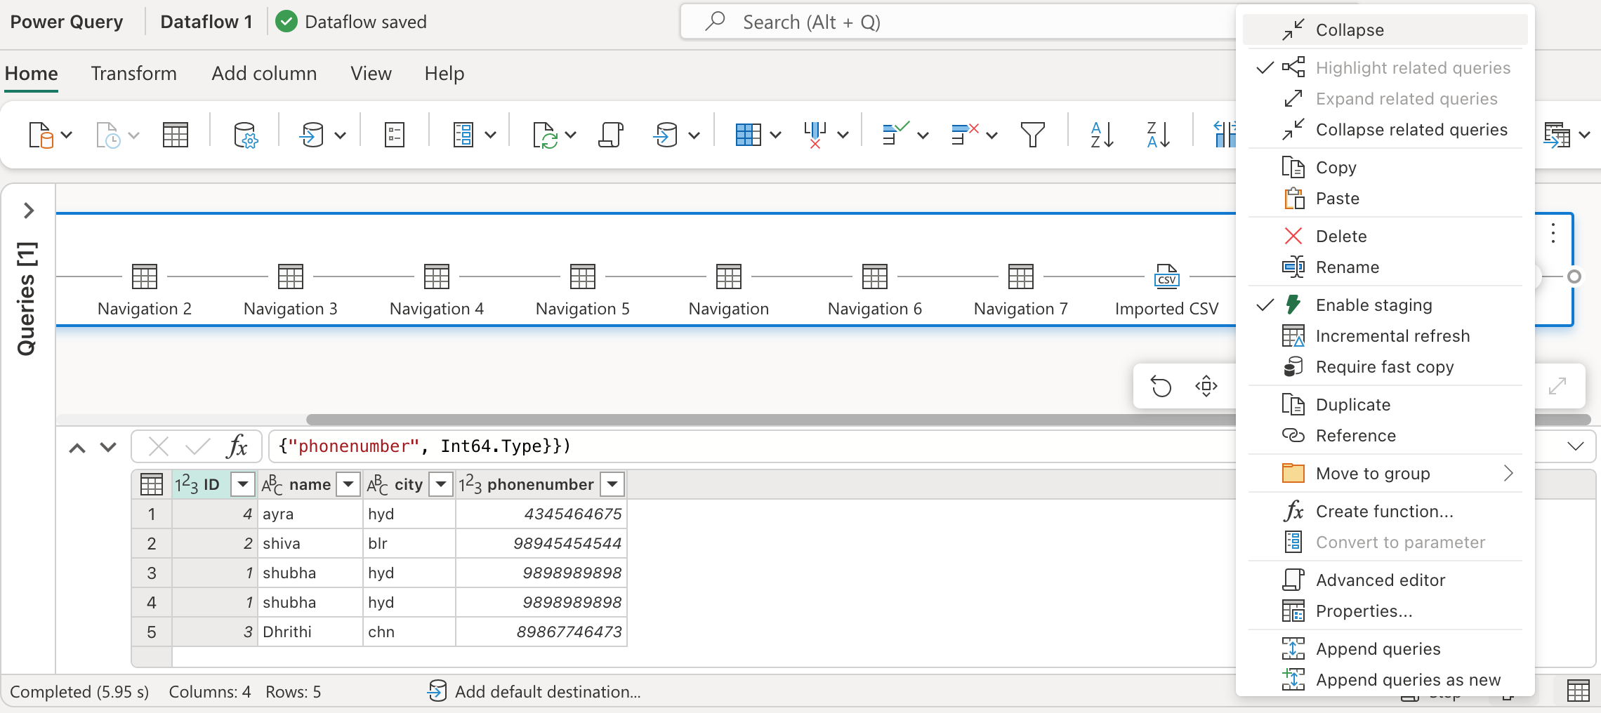 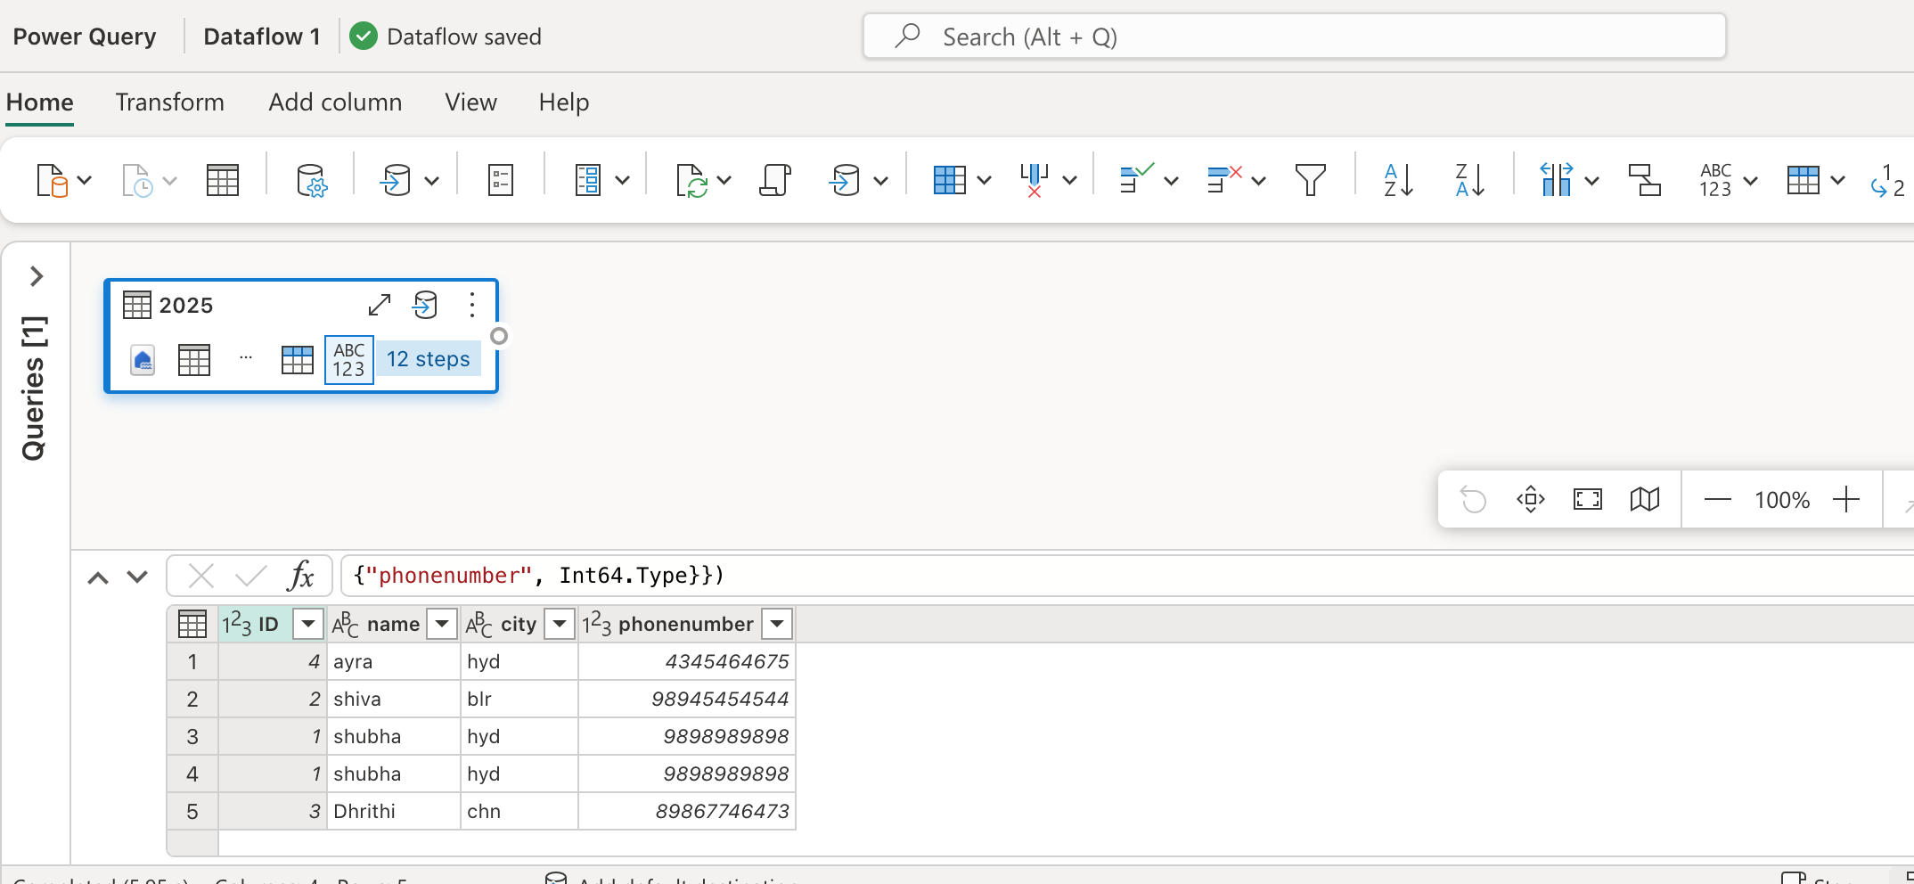we can add new source to this , either it can be same workspace or different workspace, and we can also use warehouse or different source

go to new source , and select whichever u want to select

lets select the same warehouse and select a table

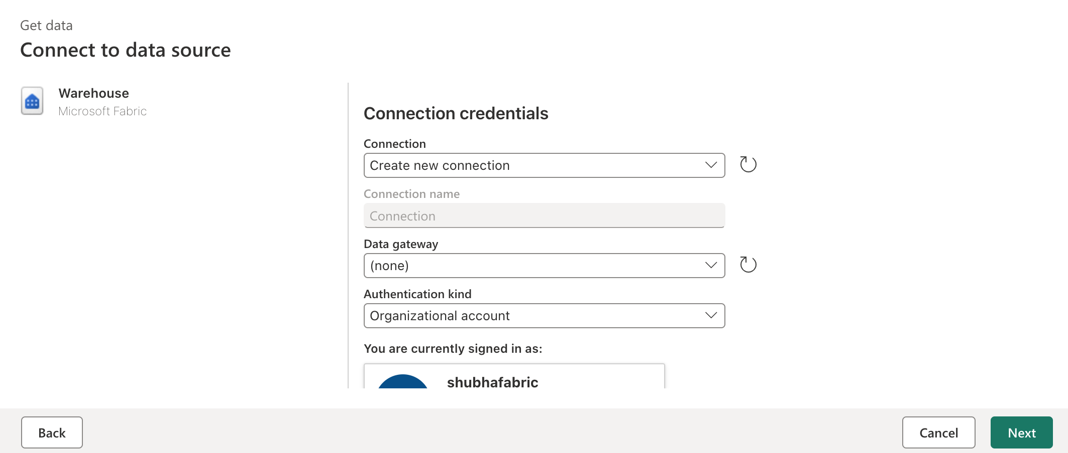 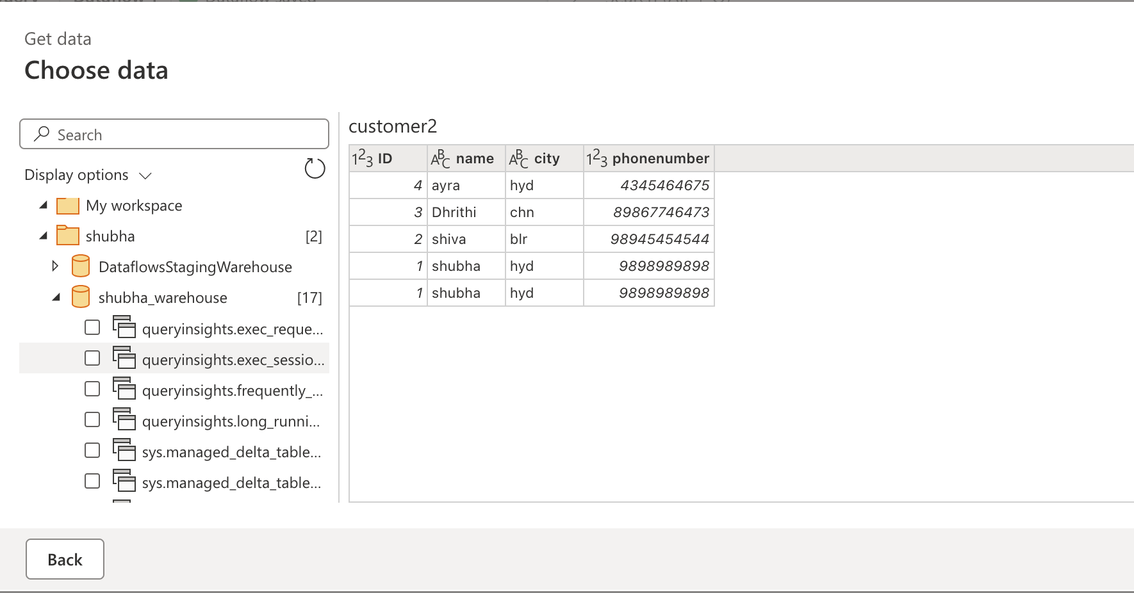lets create a second table along with diagramatic view 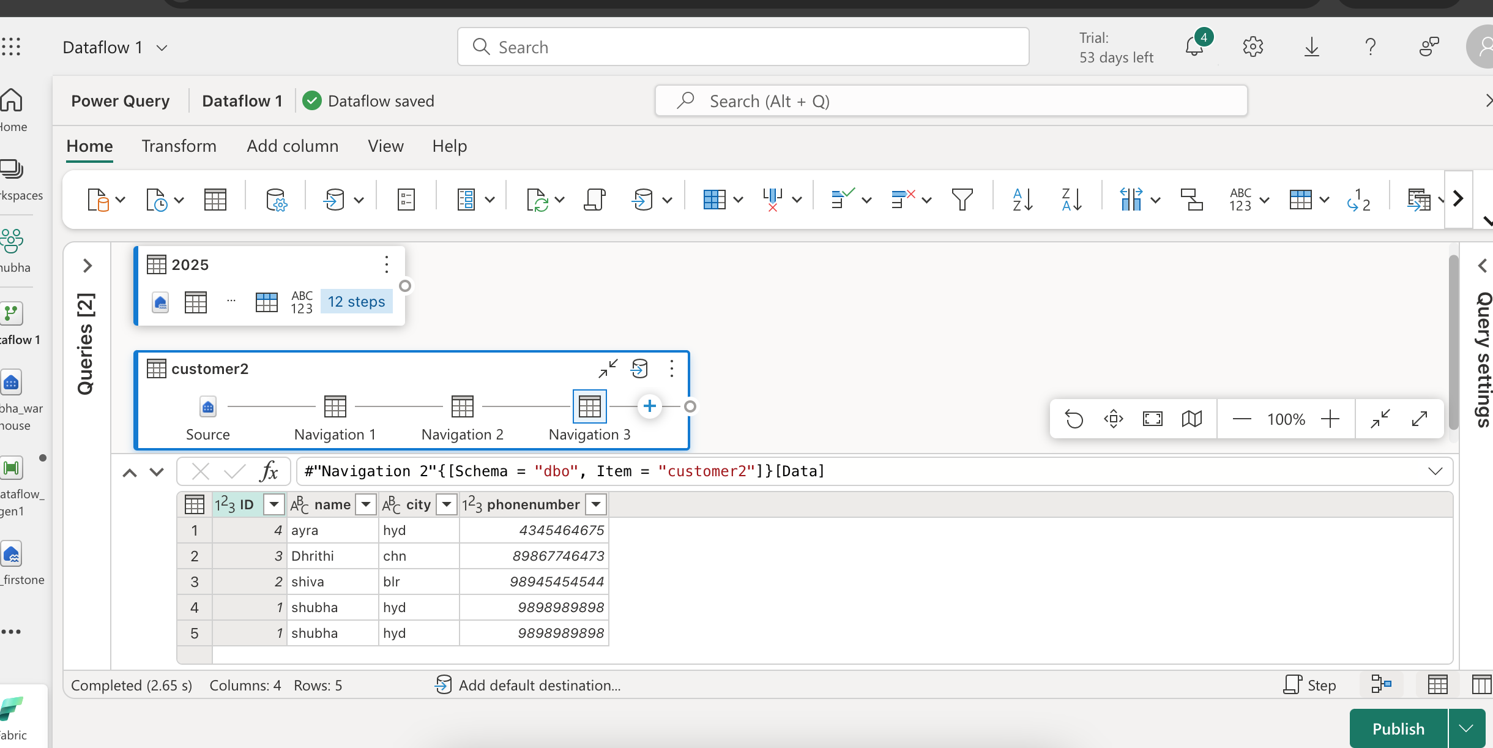Now lets add third table using warehouse same as second table

As we already had a connection for warehouse 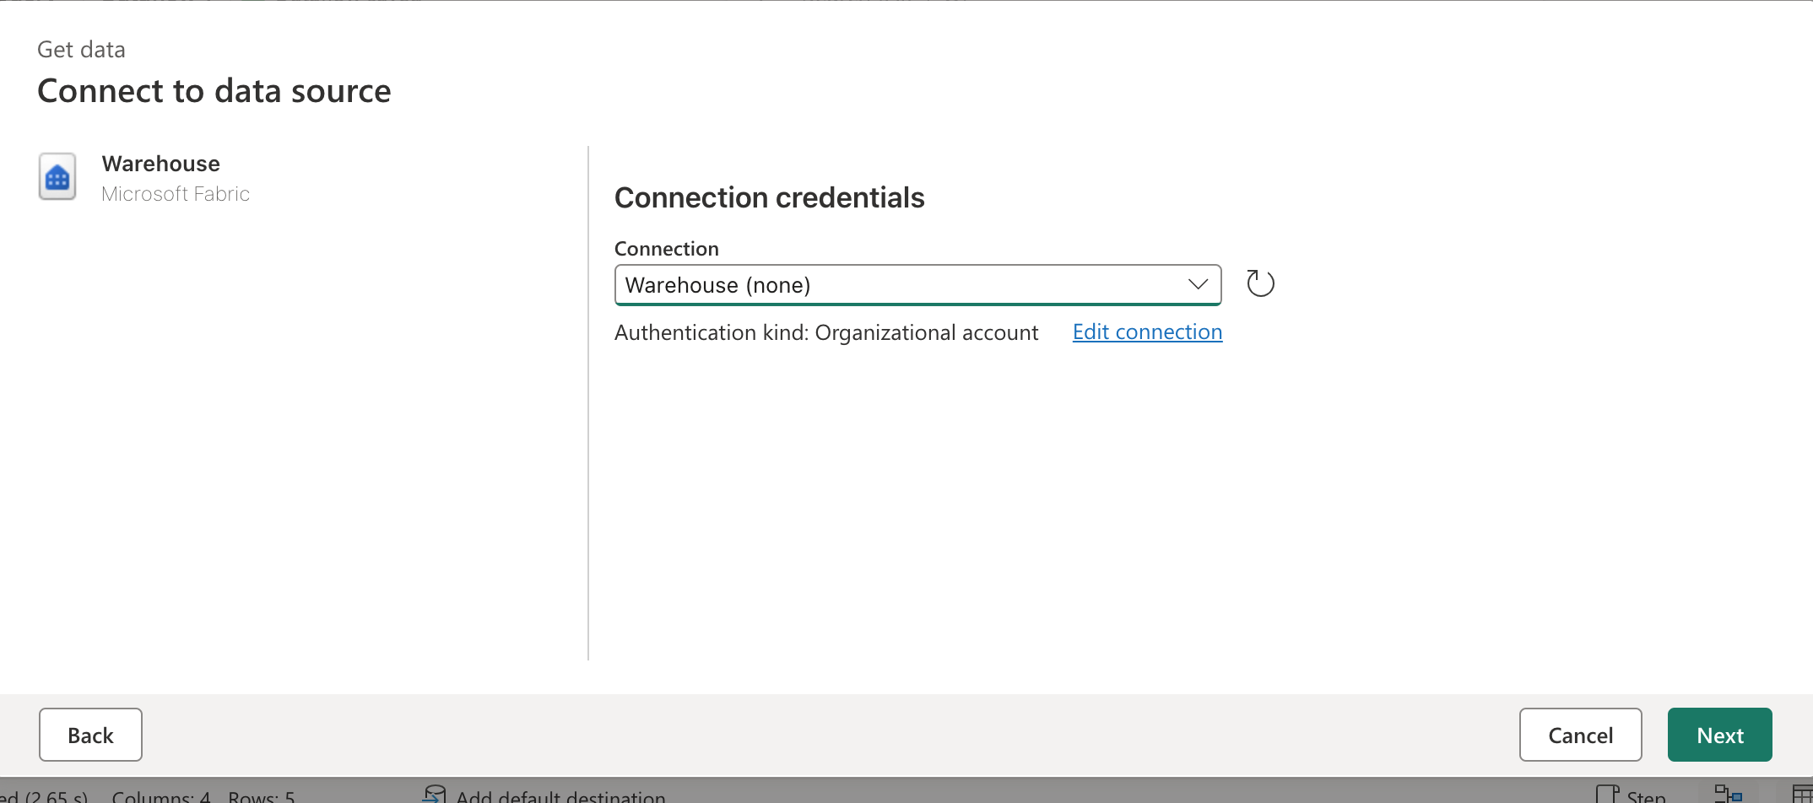 select a table 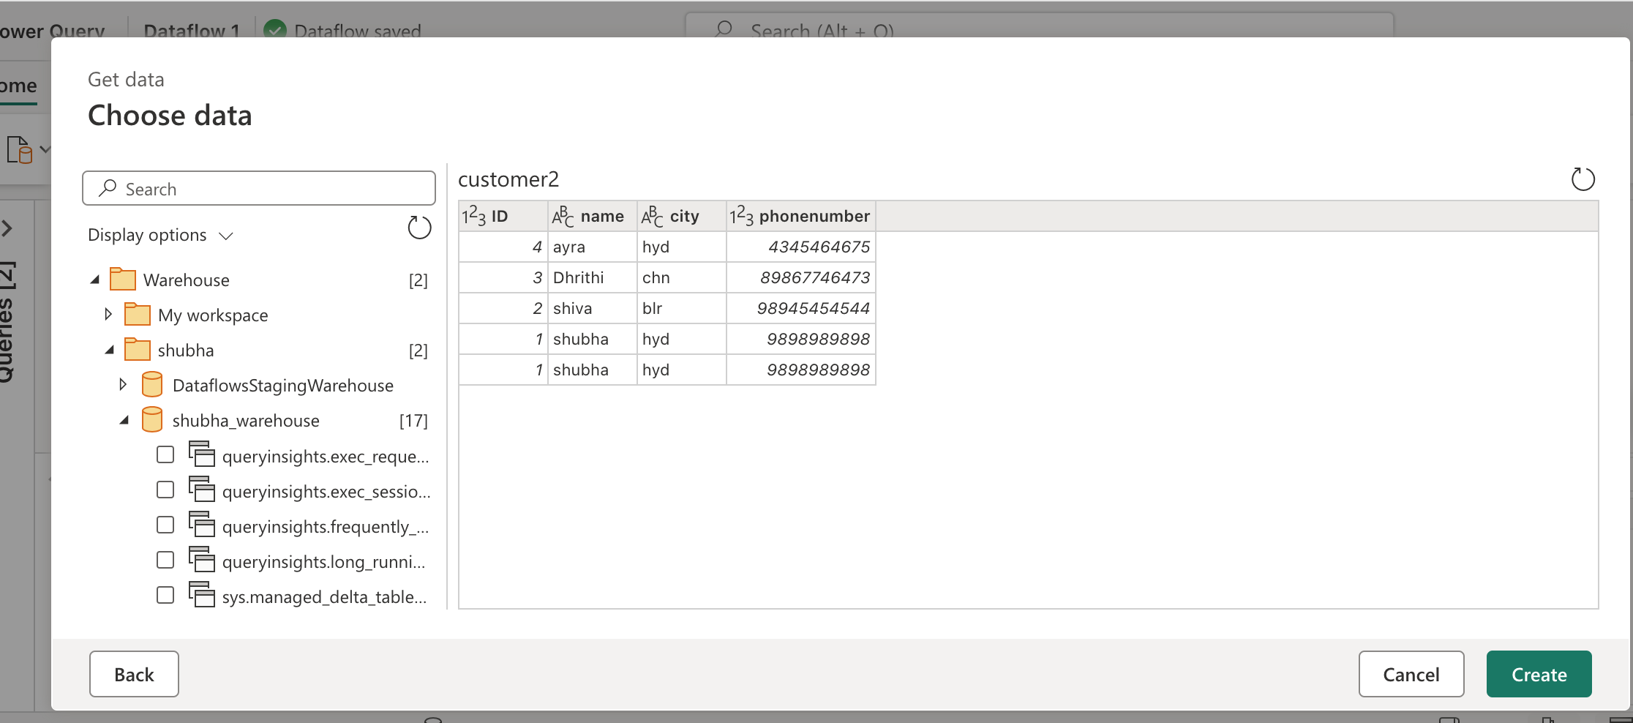 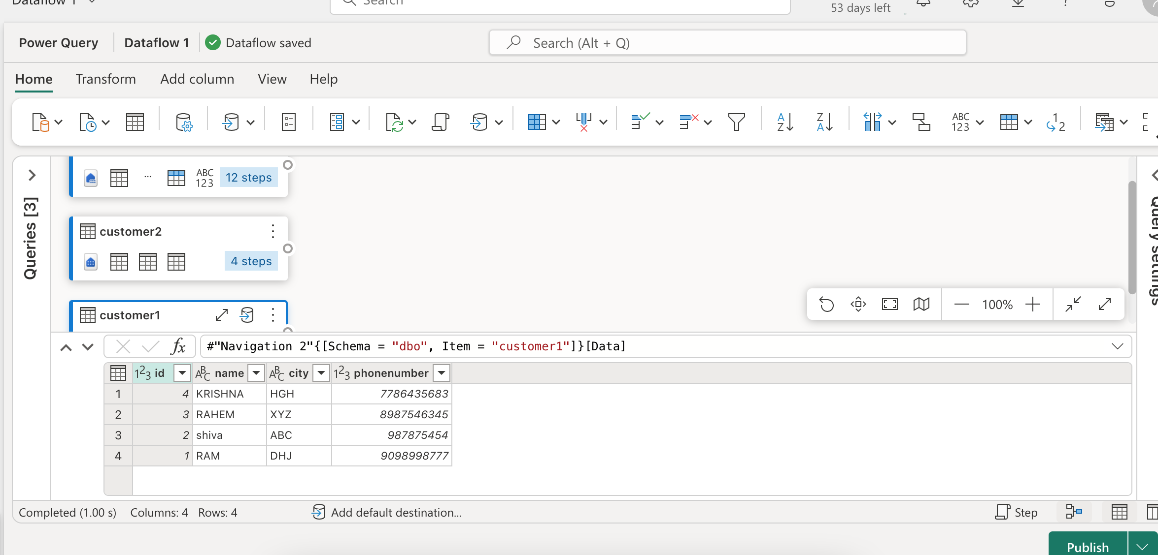All the three sources are added

Lets append all three tables

Right click to any one source and click on append queries as new

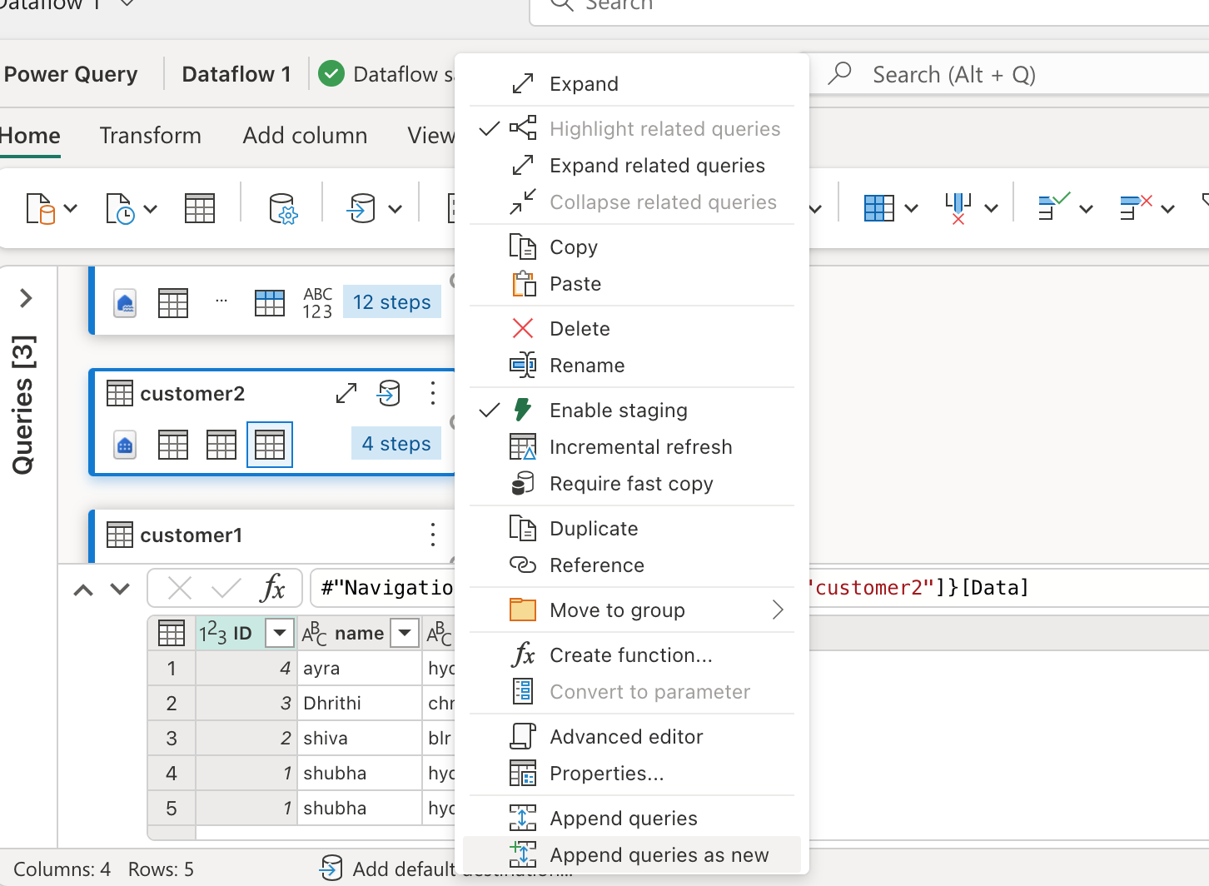 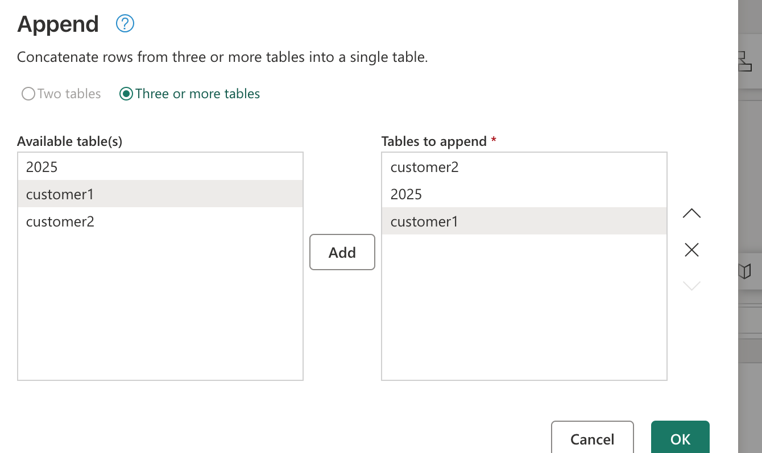 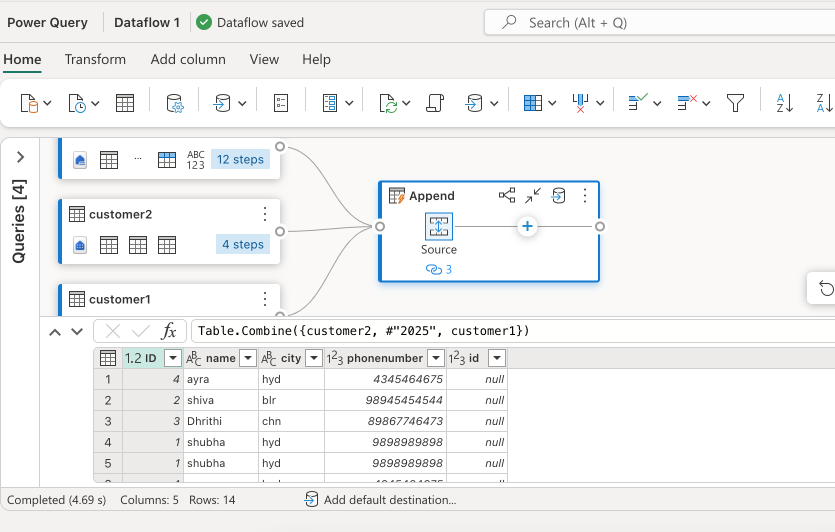 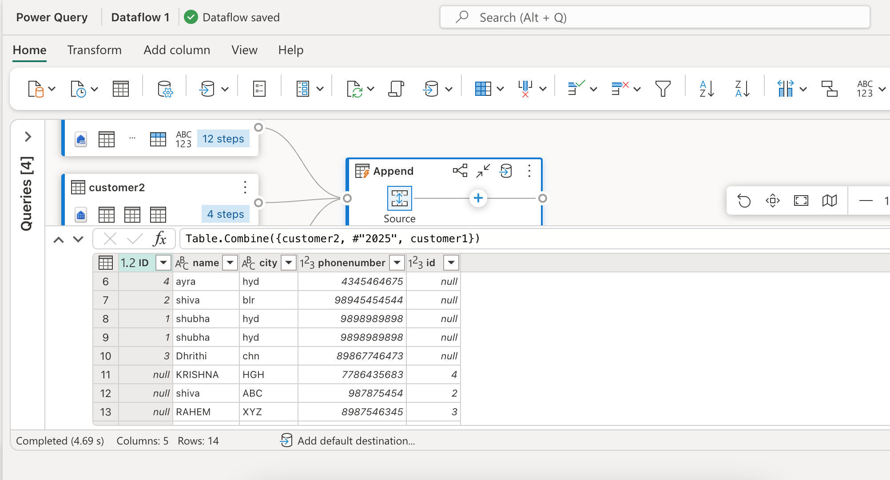after appending we see null values this is beacause may these tables have diifent column names

To avoid these error , just rename the column name

select the file/table and then rename its column

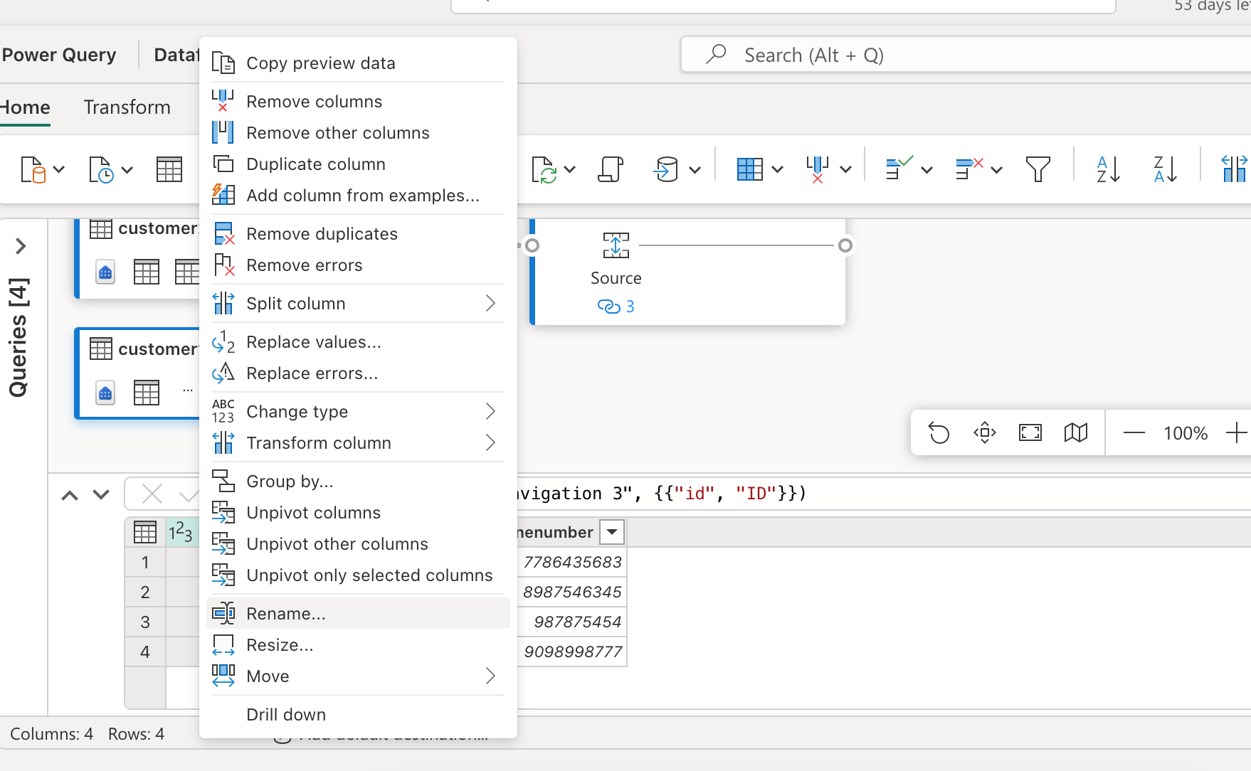 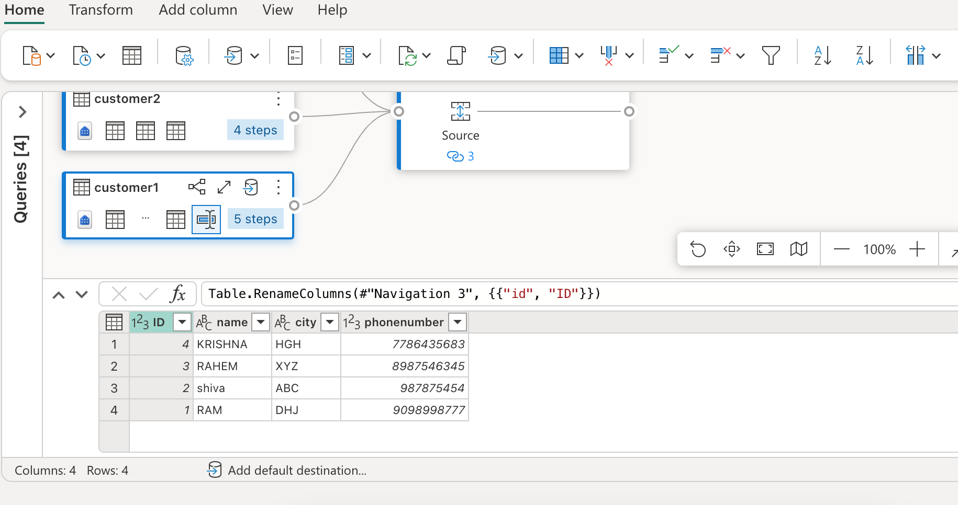 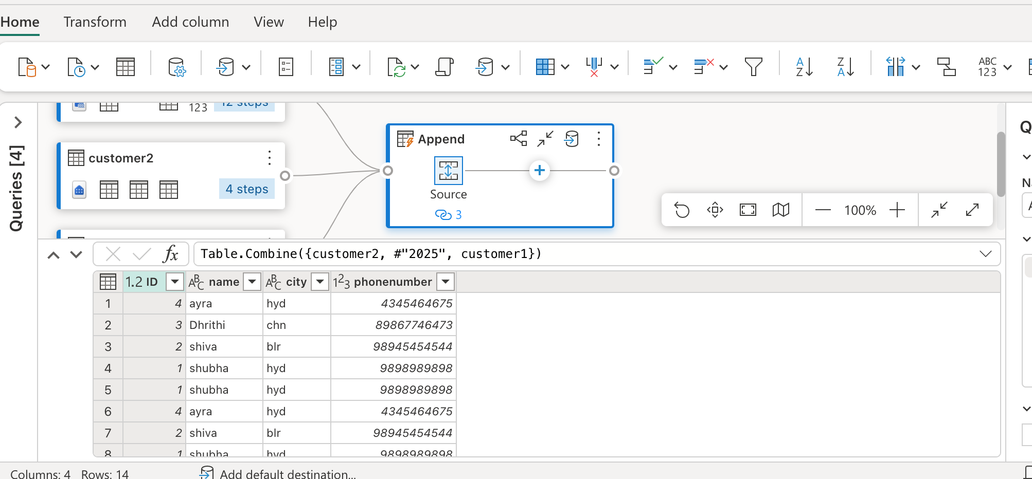now all the three tables are appended successfully

As we can see there are so many duplicate values , that we should remove by right clickinh table and select remove duplicate 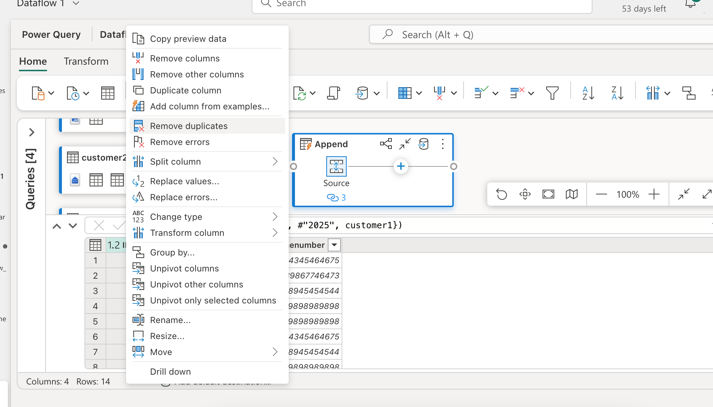duplcates are removed successfully 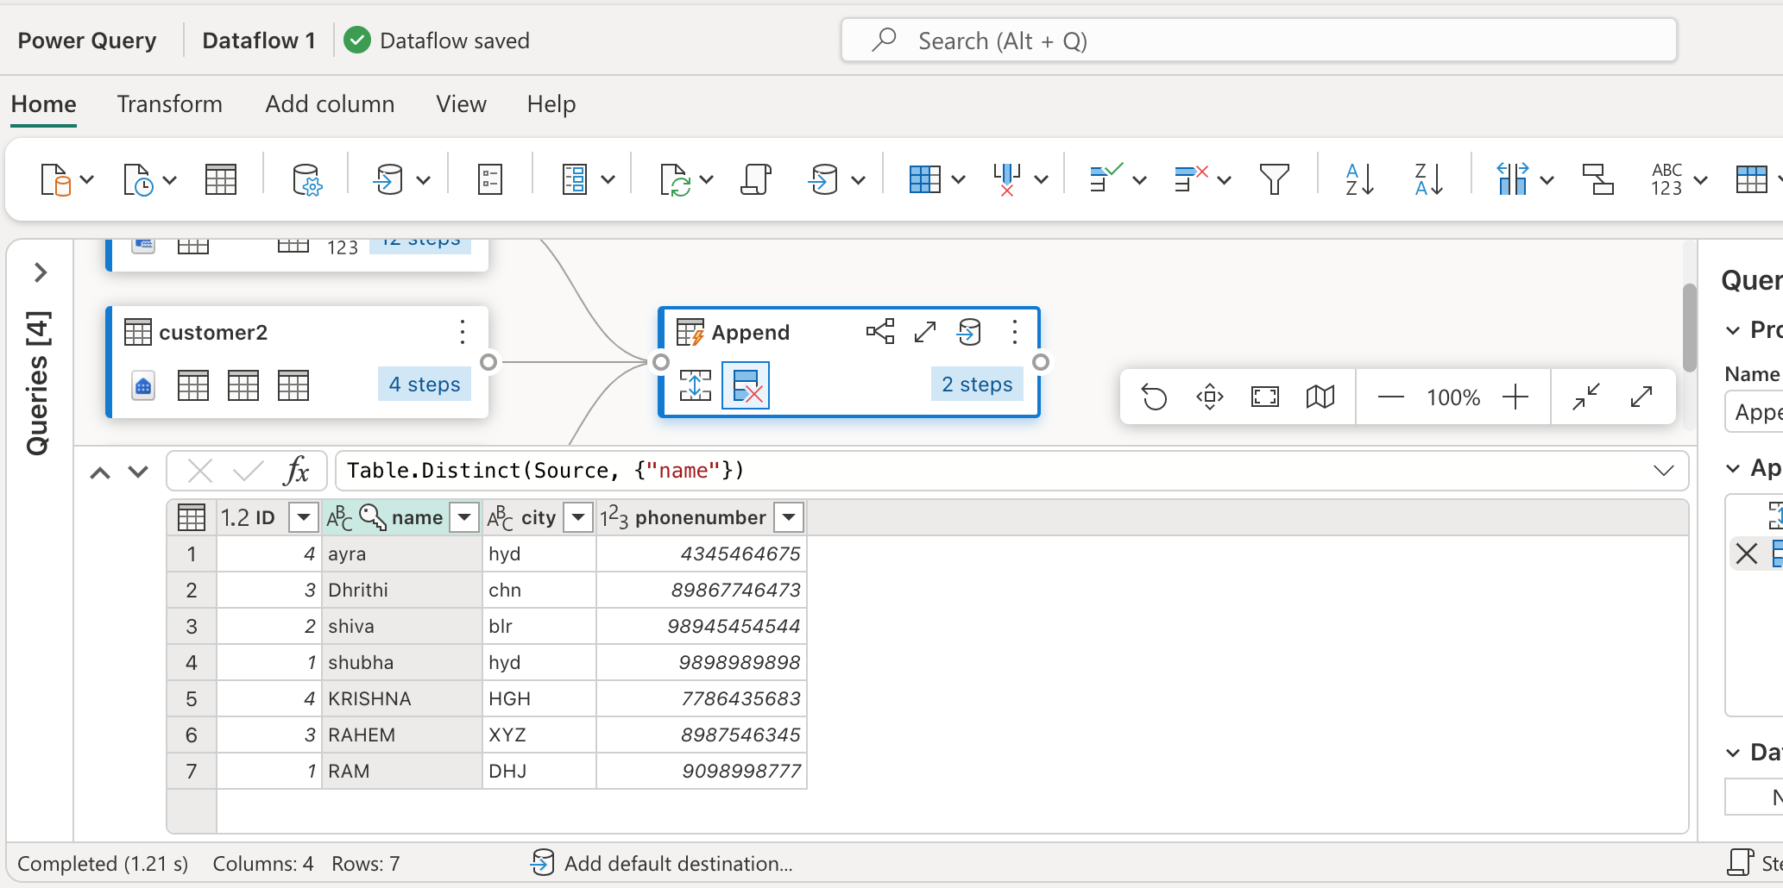this is the power script

Right side, bottom , click on steps 🡪 query script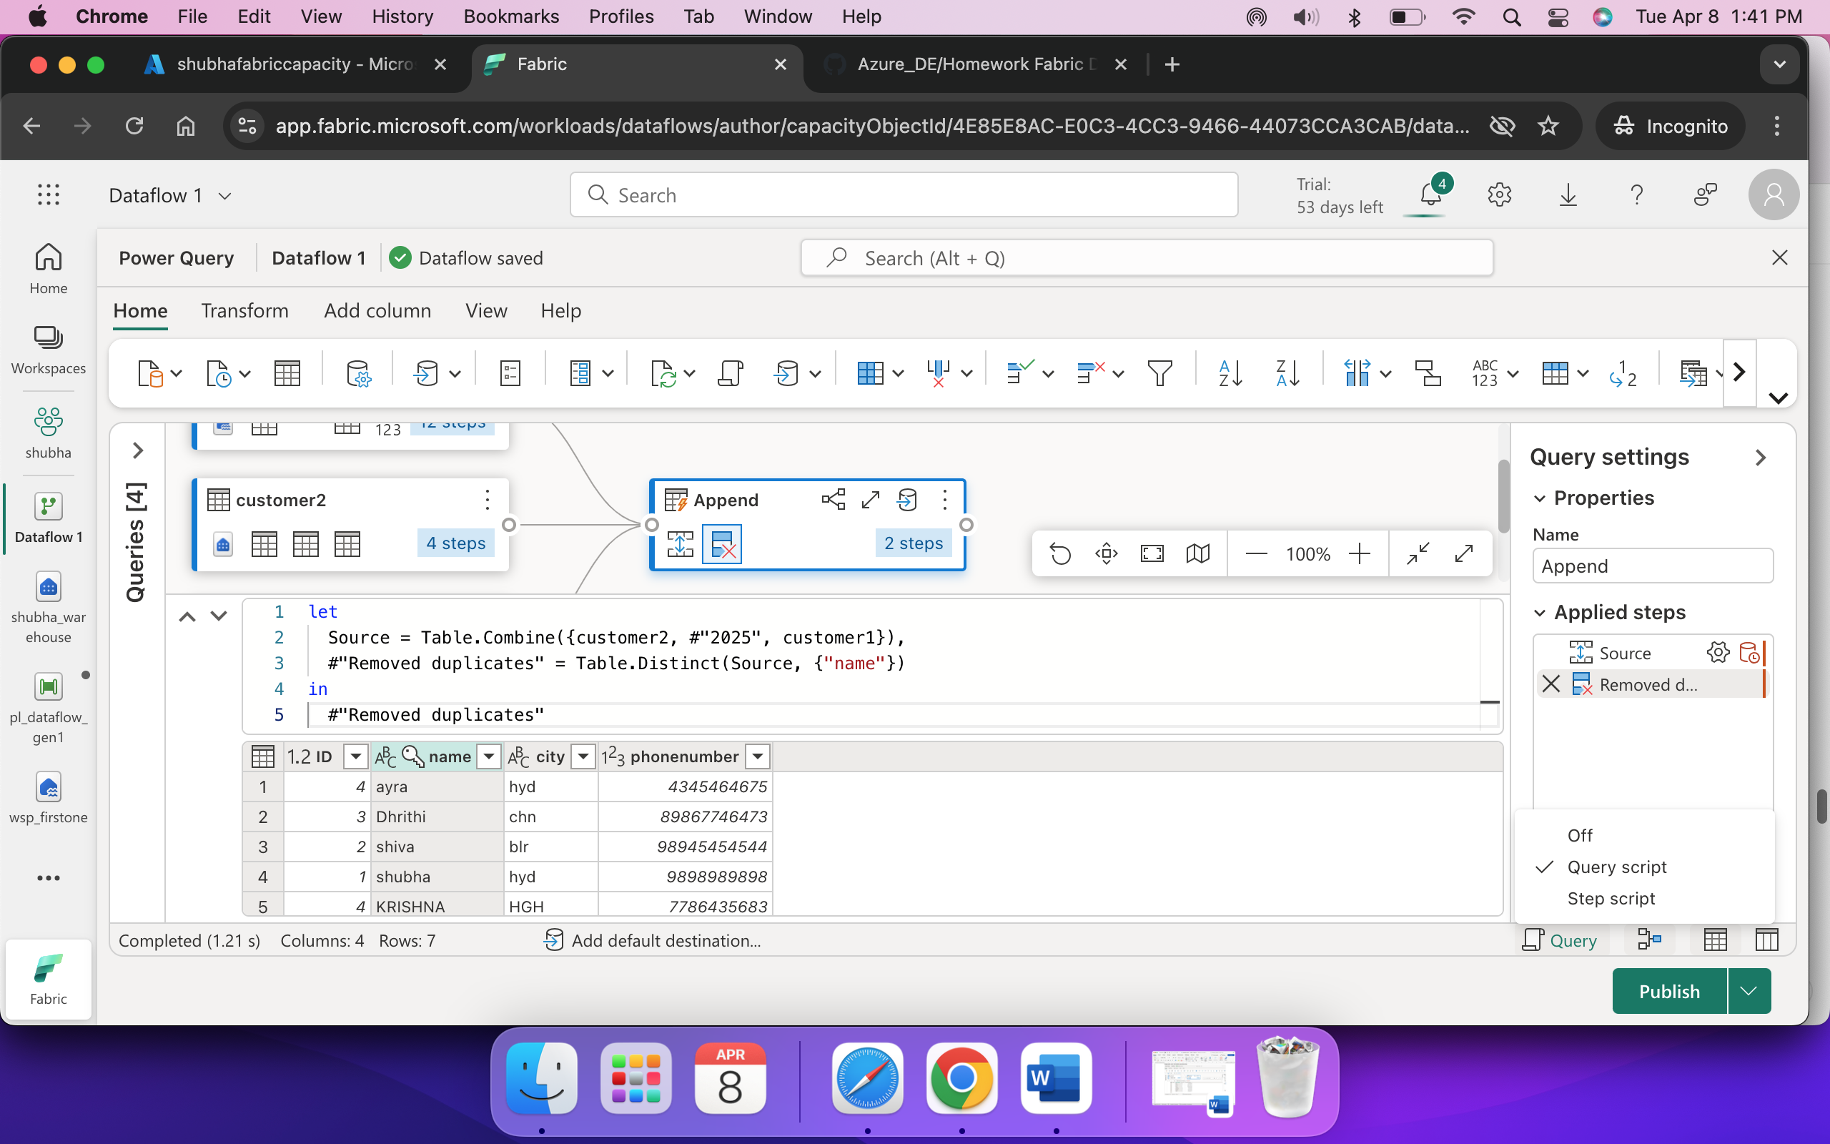lets add destination , for that click append and select data destination 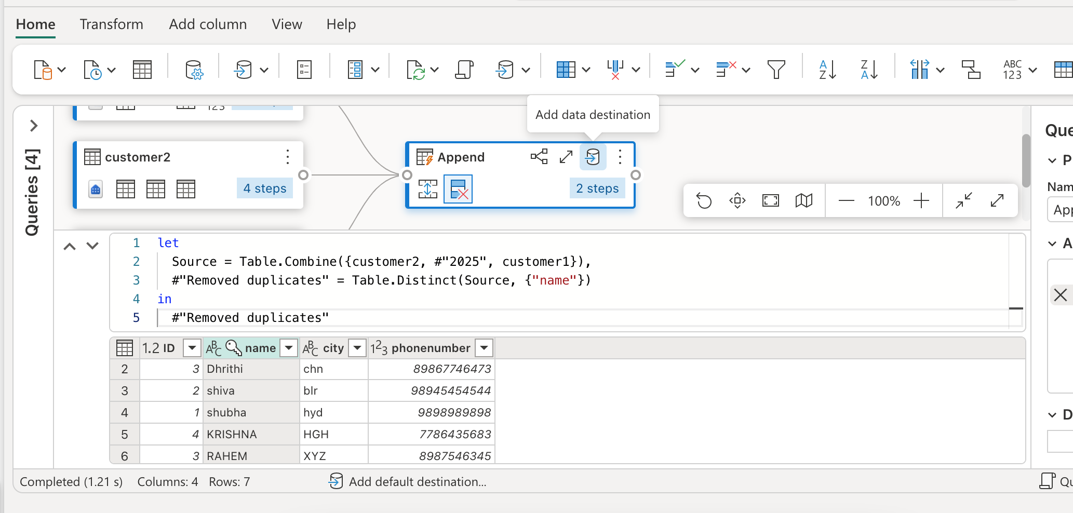 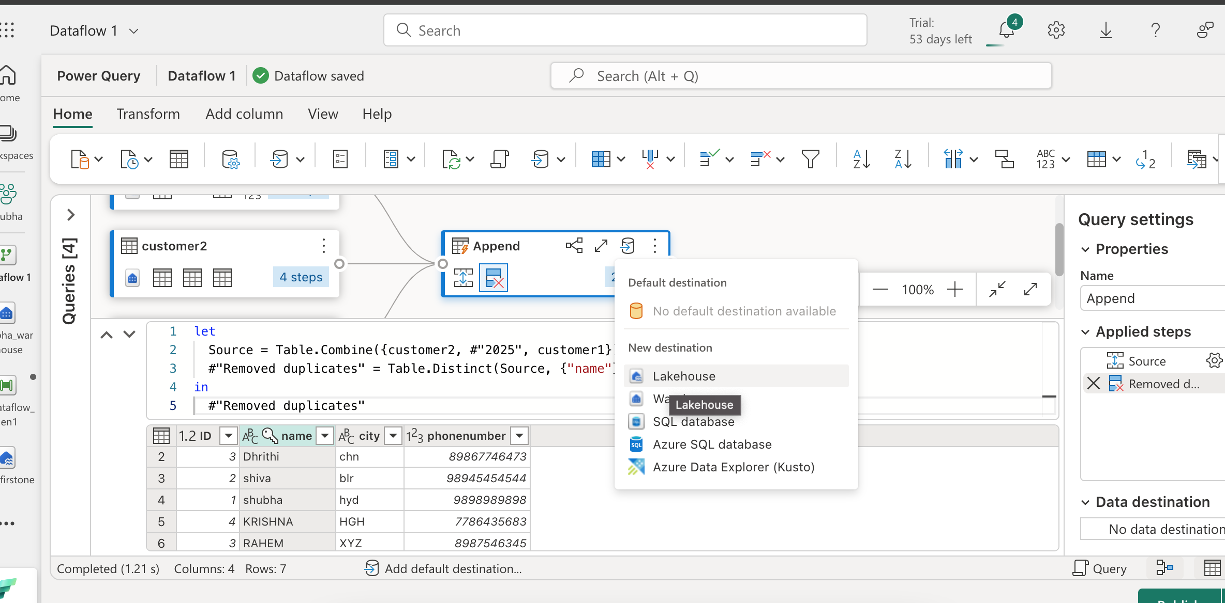lets select lakehouse as our destination 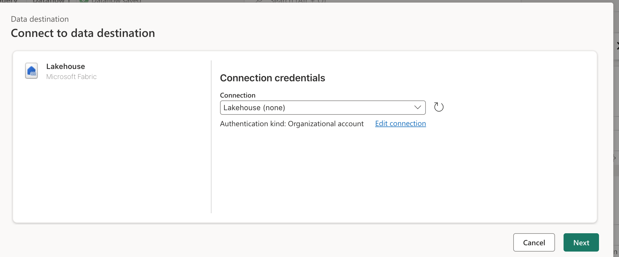 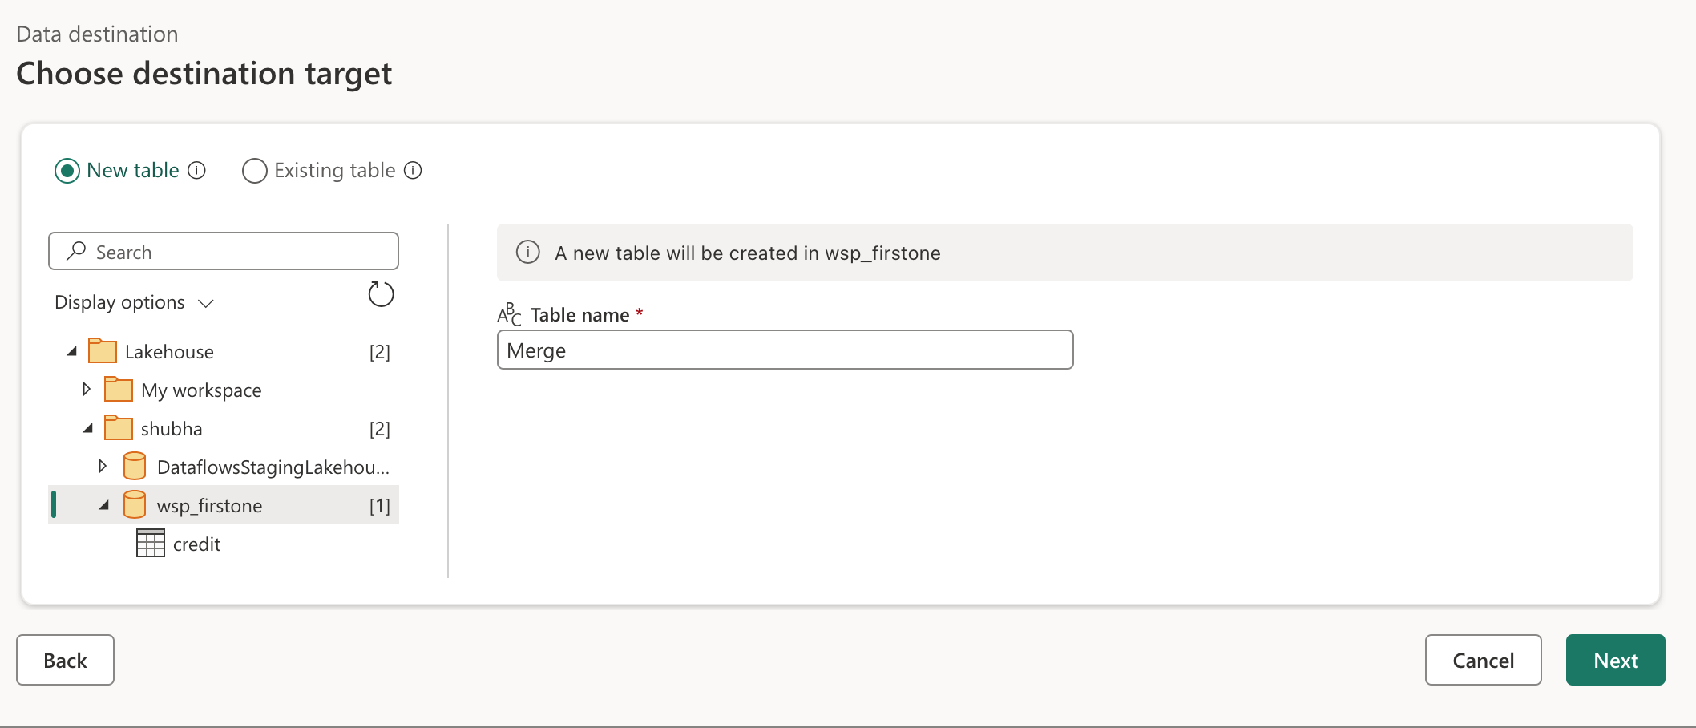 if you want to change any setting , turn off automatic setting 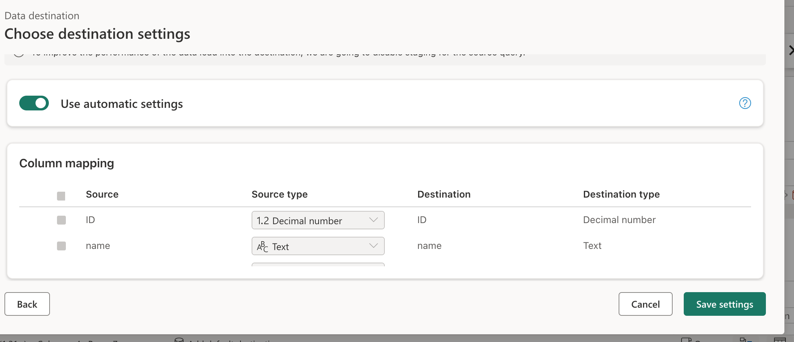destination is added 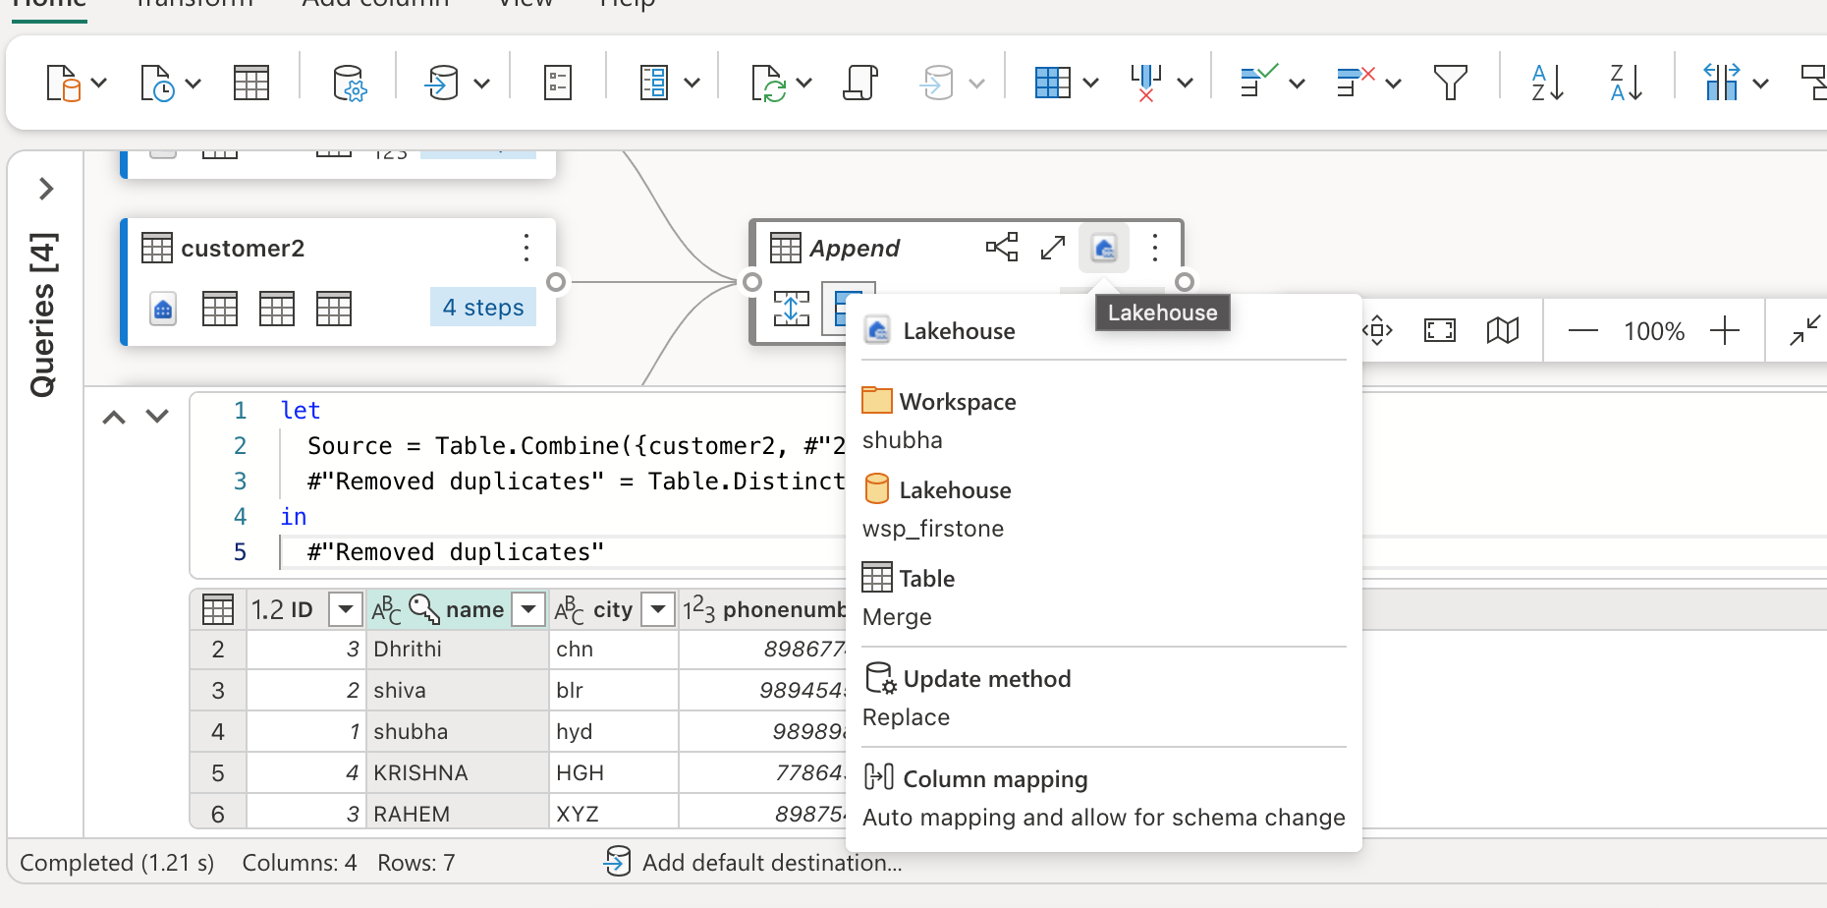lets publish the dataflow now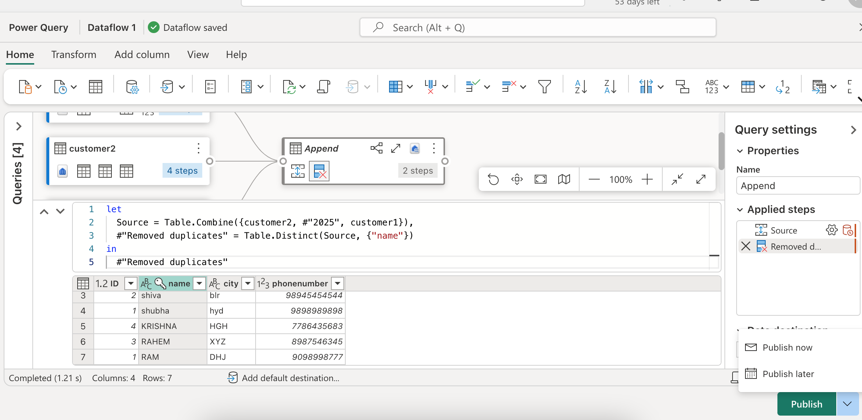 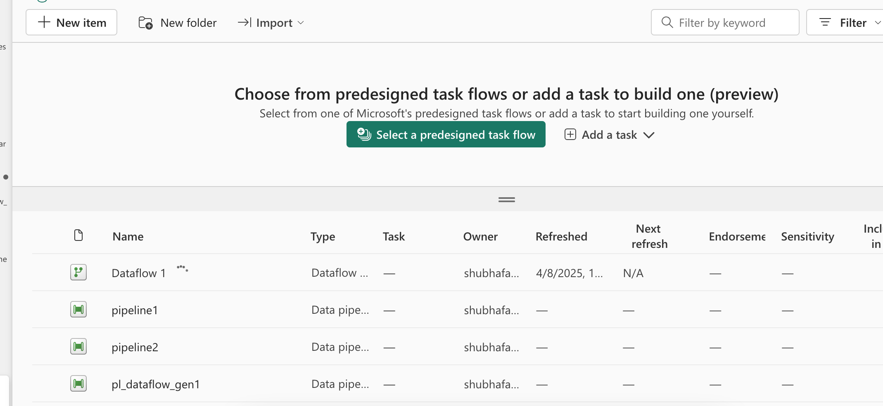 dataflow is published successfully 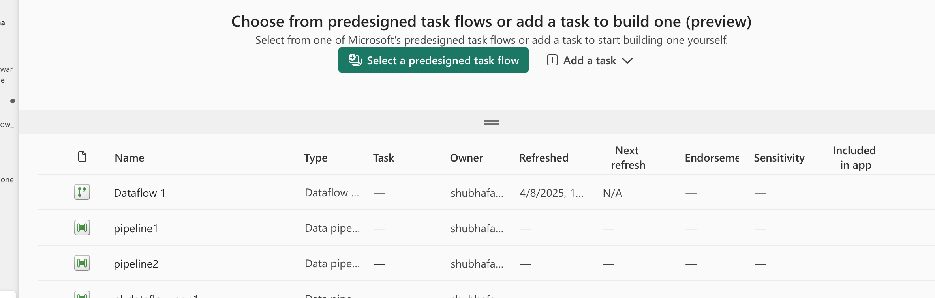lets check the data , as we selected our destination as lakehouse ,check there

Data got loaded successful in lakehouse

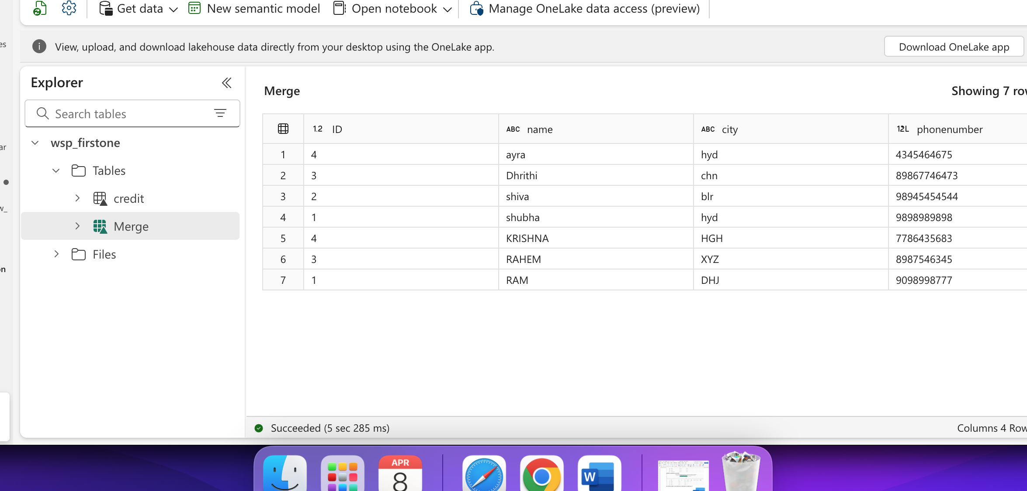To generate report , go to SQL analytics endpoint 🡪 reporting 🡪manage default semantic model -> select which table you want to generate report for 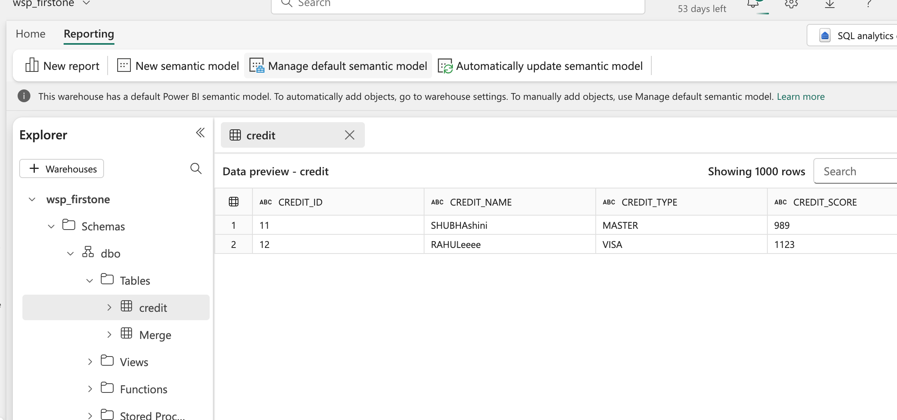 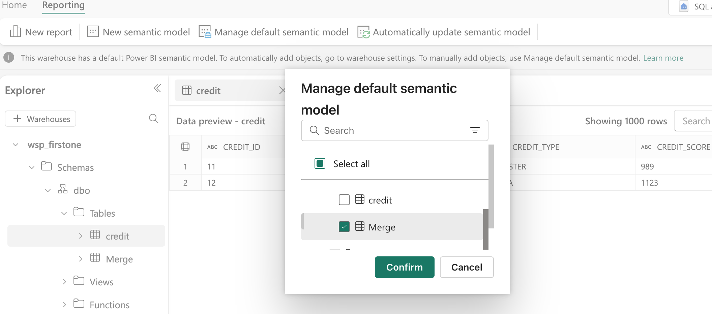 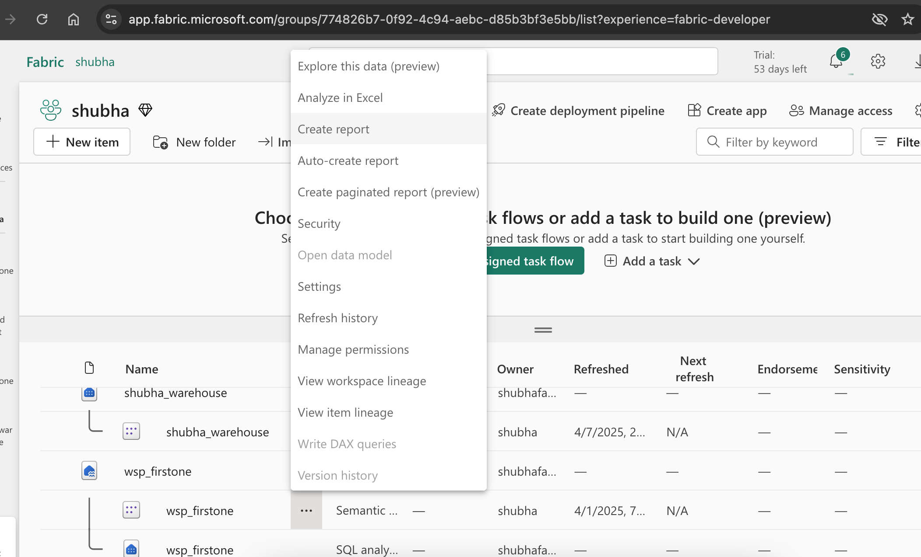 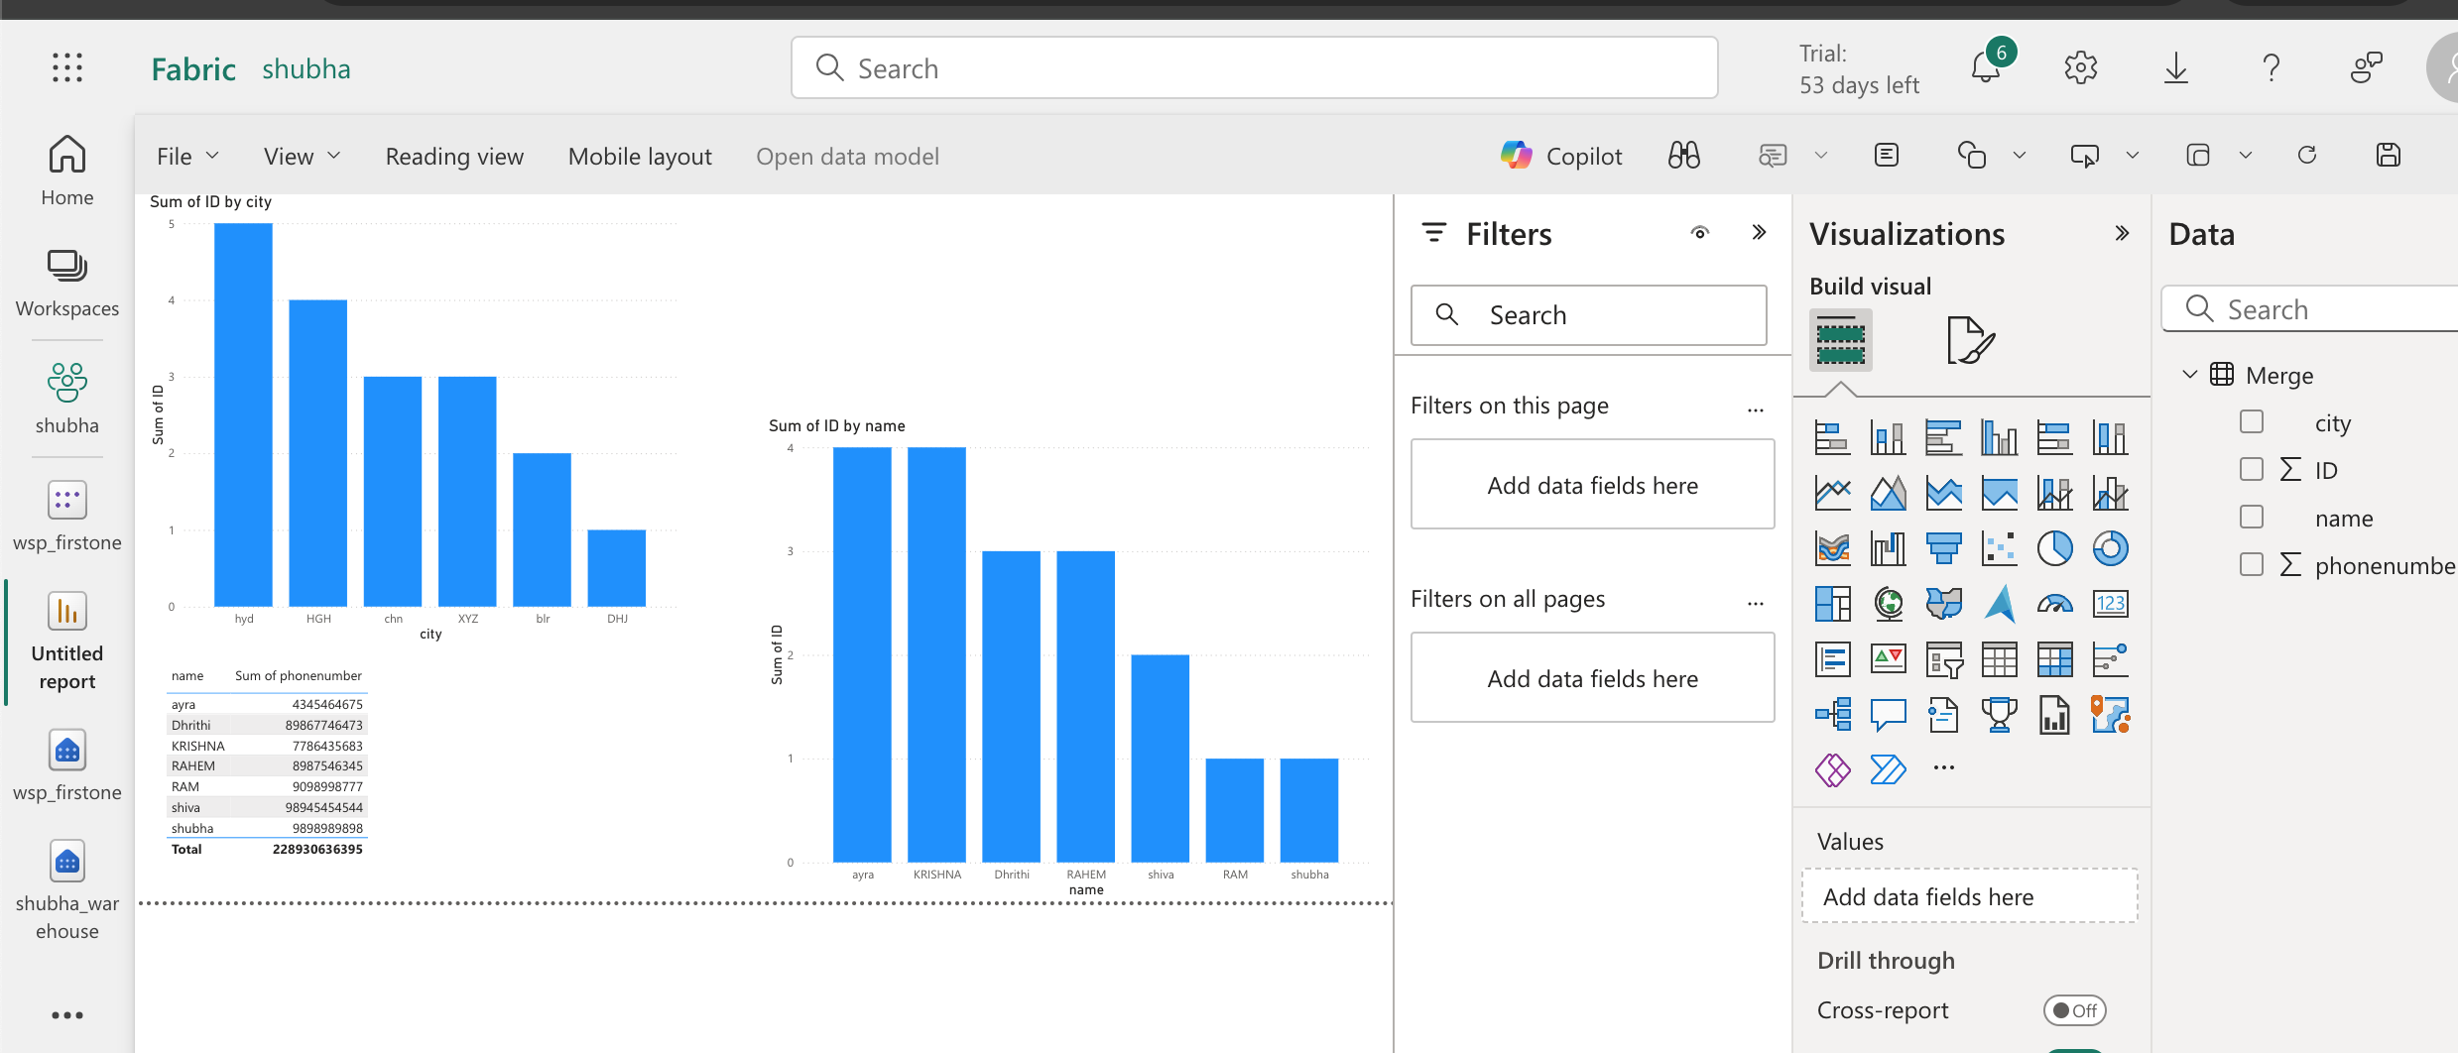Report is generated successfully

We can add new column in dataflow 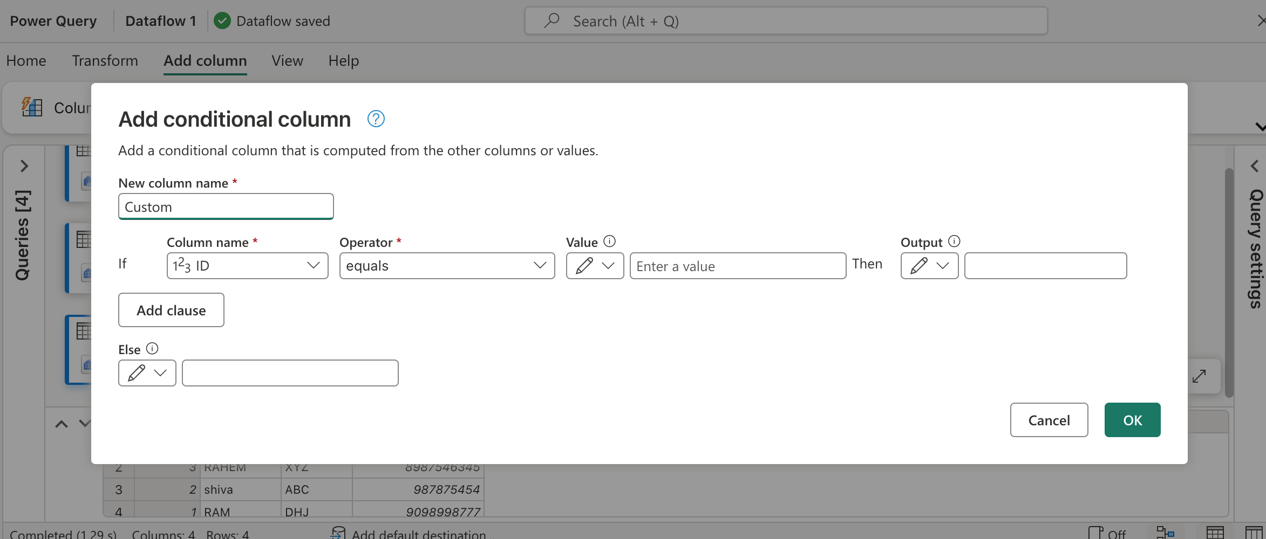This is how we create a conditional column , this we can use while applying SCD type logic